Vedavyasa Institute of Technology, Karadparamba
Seminar
Program: Awareness for TRENDING TECHNOLOGIES IN IT | Title of activity: CSI
Organizer: Department Of CSE , VVIT | Name of coordinator: Shibi B,  Asst Prof  Ranjana C ,Asst Prof | Date: 21/12/2022  10:00 am to 11.00 pm
Summary of activity:
Department of CSE VVIT's CSI chapter, in association with Jetking Infotrain LTD had conducted a Professional Orientation session on TRENDING TECHNOLOGIES IN IT
On 21st December 2022 at 10am. The session was handled by Mr. Jaikishen Ramakrishnan and Ms. Ardhra Sathyan, members of JetKing Kochi Learning Center. All the students of CSE department attended the session. the resource person discussed about the various trending scenarios of IT field which could be taken as a prospective career opportunities.

Benefit to Students /Faculties:

Knowledge on recent trends in IT.
Various job opportunities in IT.
No of participants: 50
Name, designation of external resource person with his comments:
Mr. Jaikishen Ramakrishnan(director)
Ms. Ardhra Sathyan,(HR)
The above mentioned activity was schedule in accordance with the requirement of CSI ,behalf of Department of CSE. The seminr was a fair / /good success.

Name of Head of Department: Dr. S Kavitha Murugesan Signature
Documents accompanying: Screenshots
The activity was conducted during this semester and has given good benefits to participants.

Dr S.Raji Rajan
Principal Date:12 December 2022

SCREENSHOTS

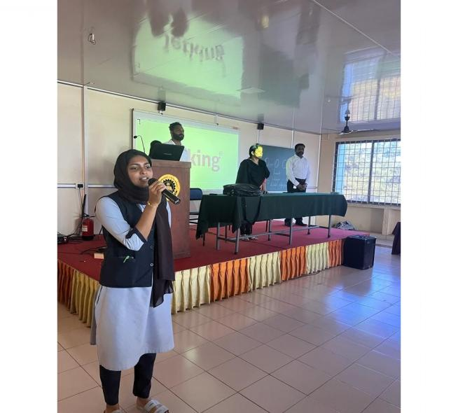 | 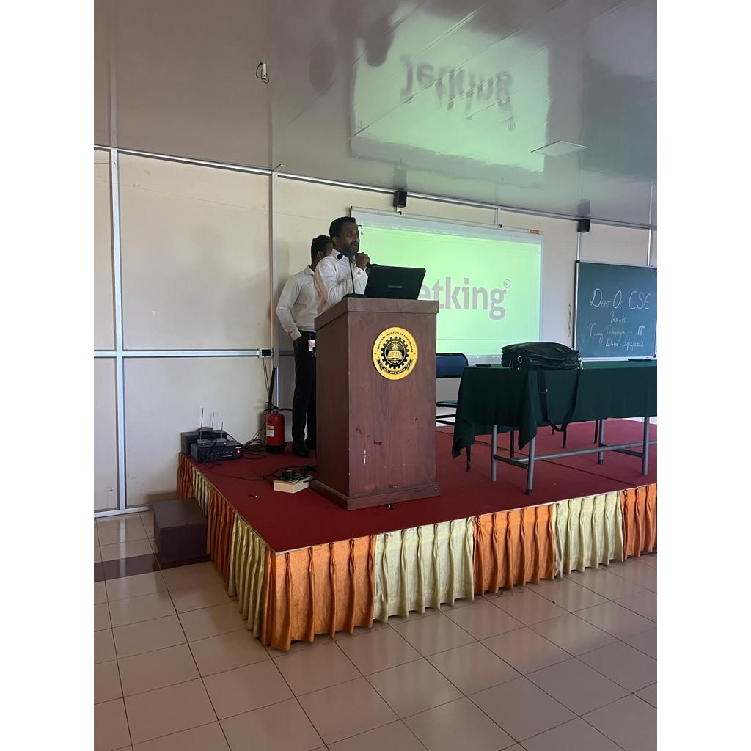
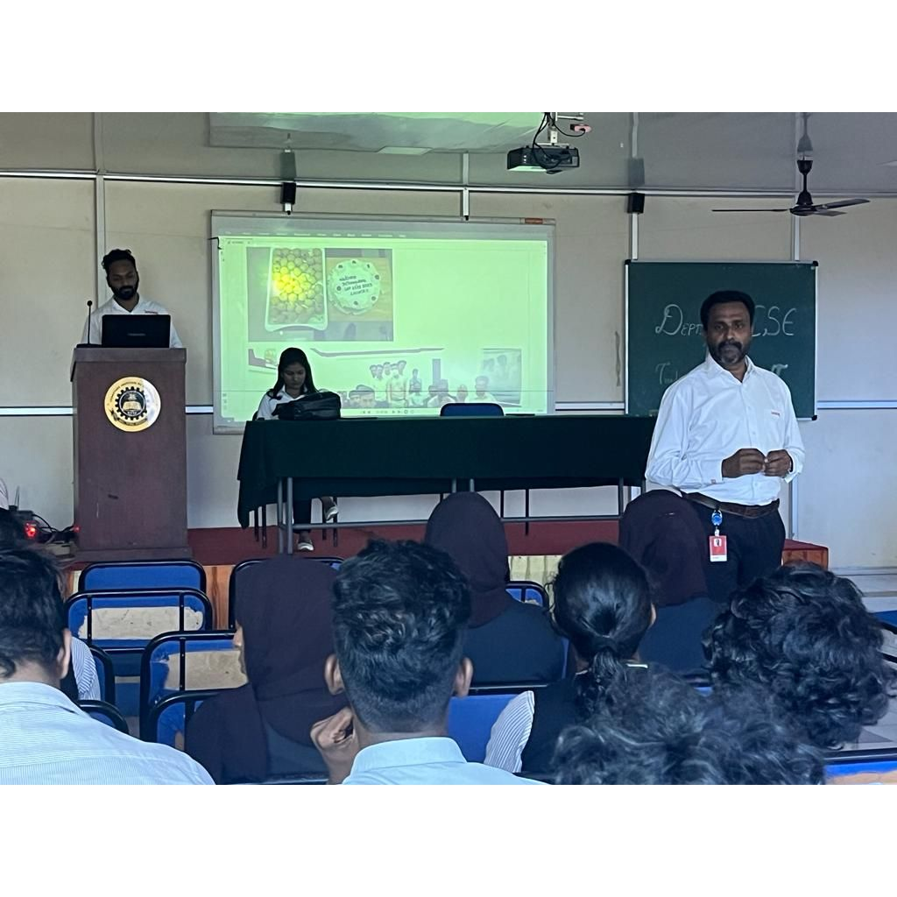 | 