IEEE STUDENT BRANCH VVIT

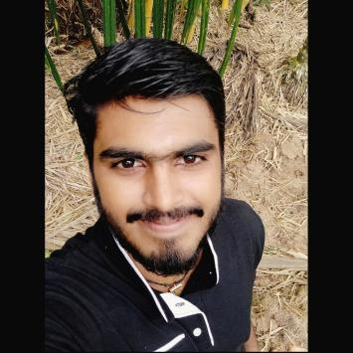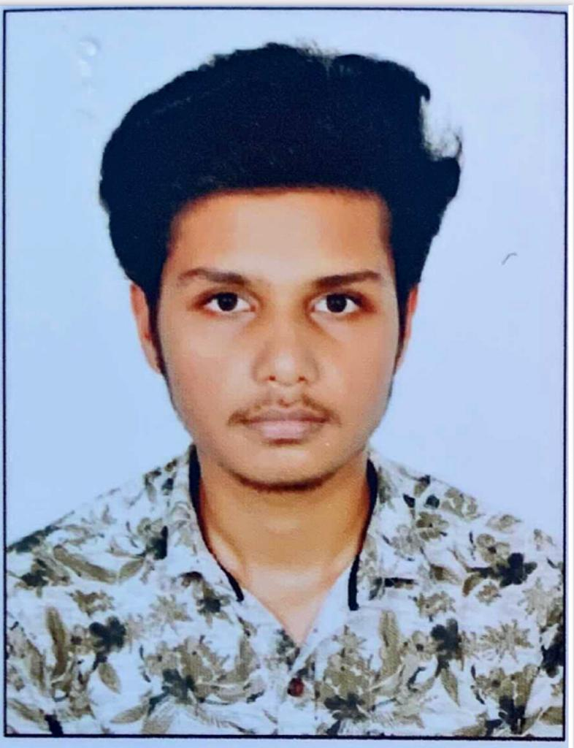

Chairman: Abhijith KS Vice Chair:Hari Shankar
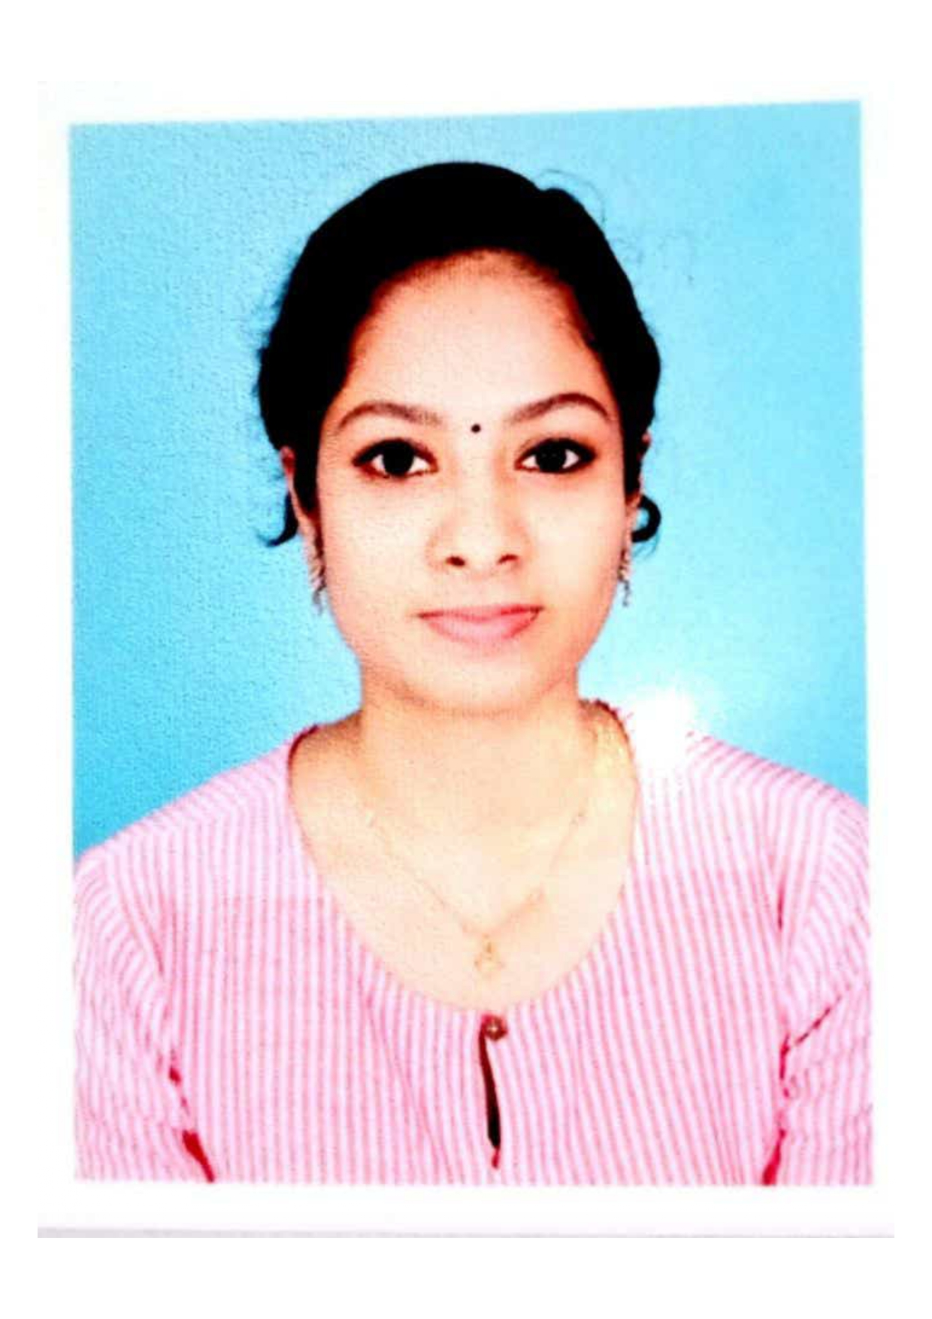
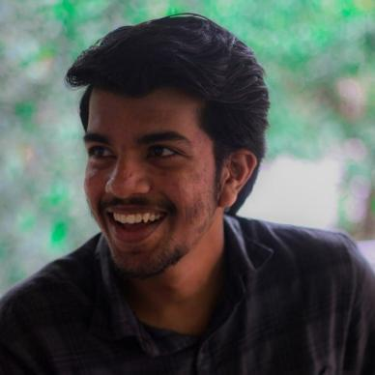
Secretary: Hari Govind Treasurer: Adhitya E

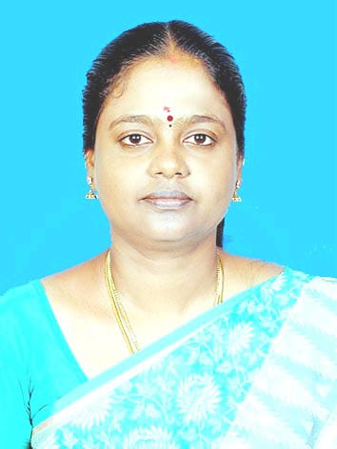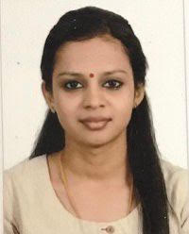
SB Counselor: Dr.S Kavitha M Staff Co-ordinator: Anjana P

STUDENT BRANCH INAUGRATION

The student branch was Inaugrated at vvit by Prof Dr.Mini Ulanat,Chair IEEE Kerala section on 5th March .with the esteemed presence of
Dr Gilesh MP(chair, student activity committee), Dr.Sabiq,(chair,IEEE Malabar section) Mr Shone Jose(vice chair student activity committee)

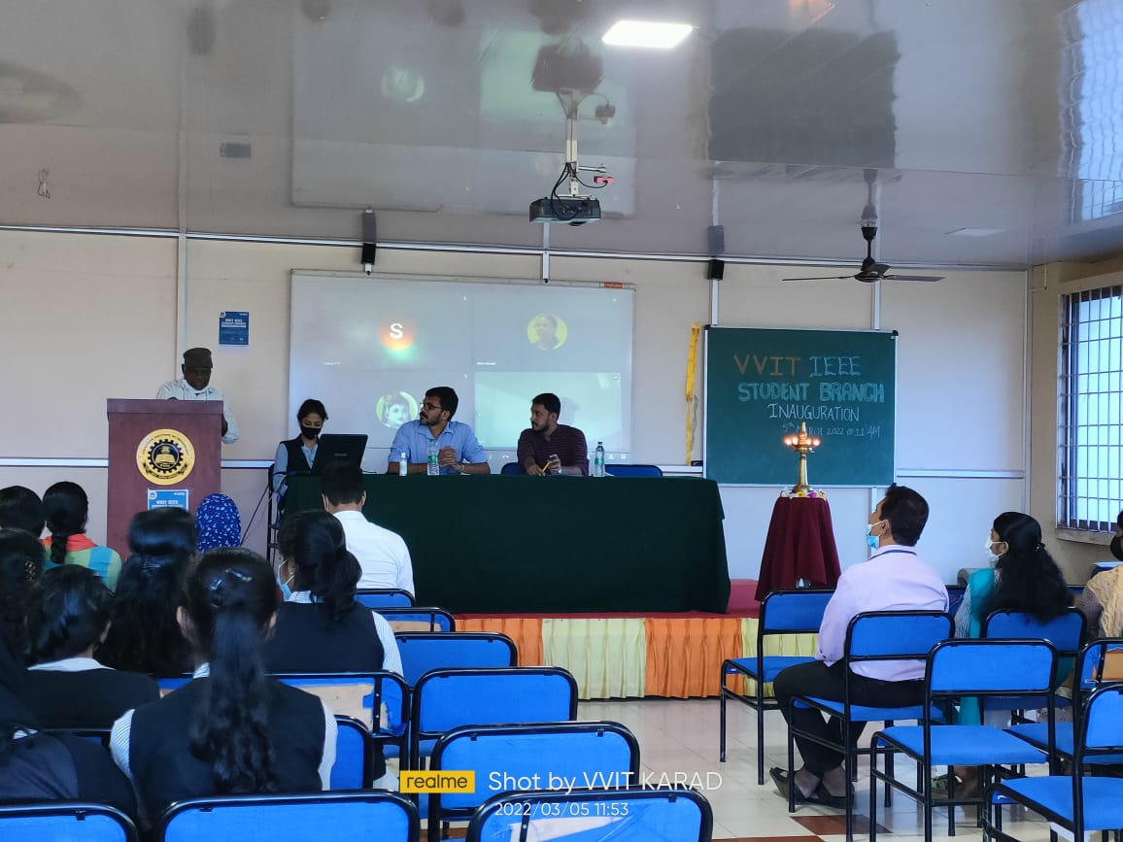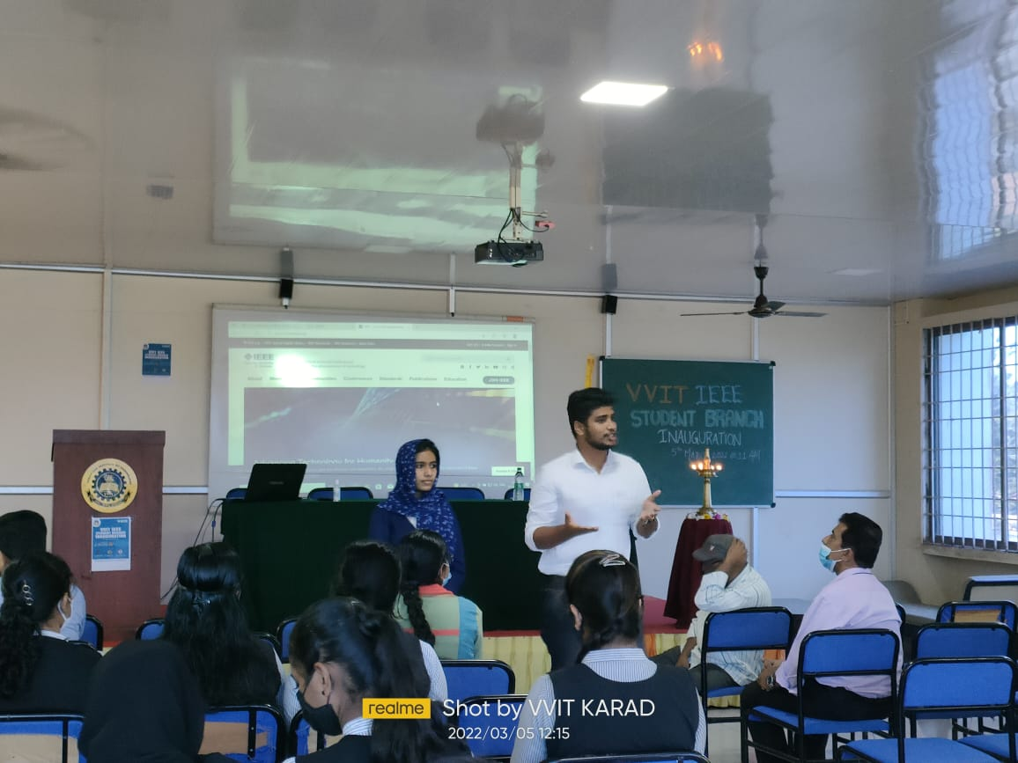

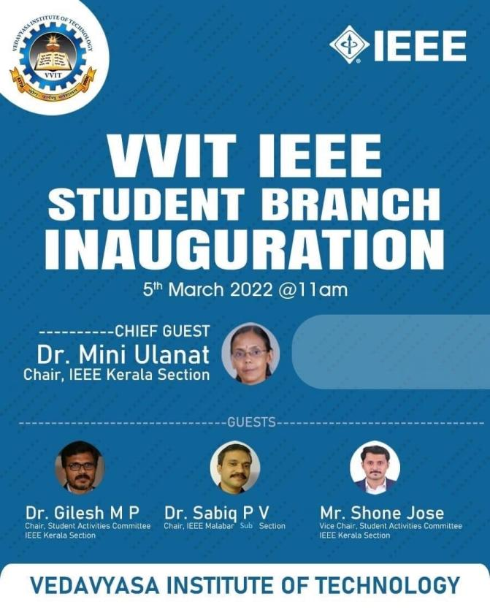

IEEE Kerala section Malabar office Visit

IEEE student branch members visited the Malabar office on 17/7/22. They were welcomed with a short session on the functioning of IEEE.
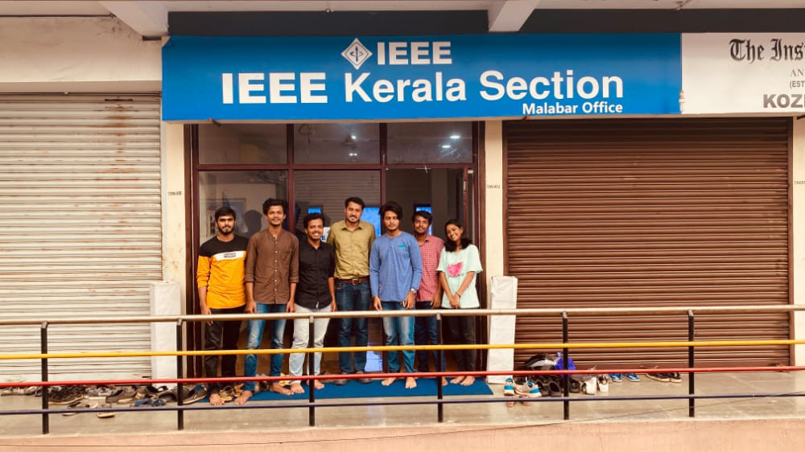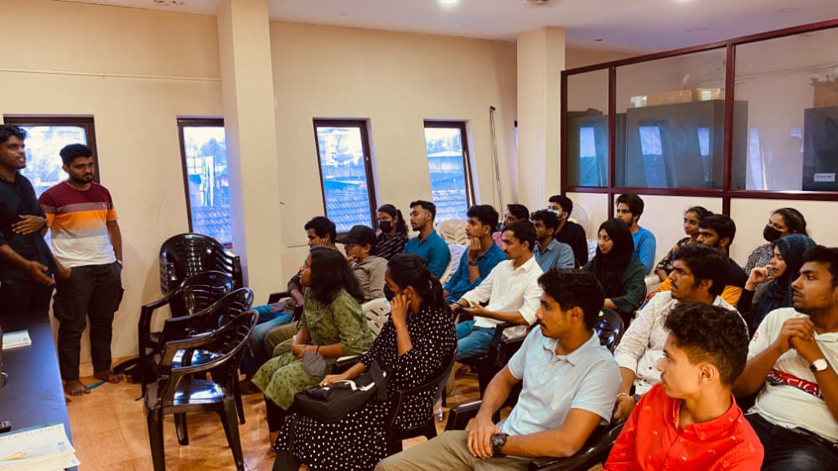

ORIENTATION PROGRAM AND MEMEBERSHIP DRIVE

An orientation program called “OUT OF THE BLUE 2.0” and membership drive was conducted at VVIT for the newly formed SB’s on 23 April 2022 by the IEEE Volunteers.
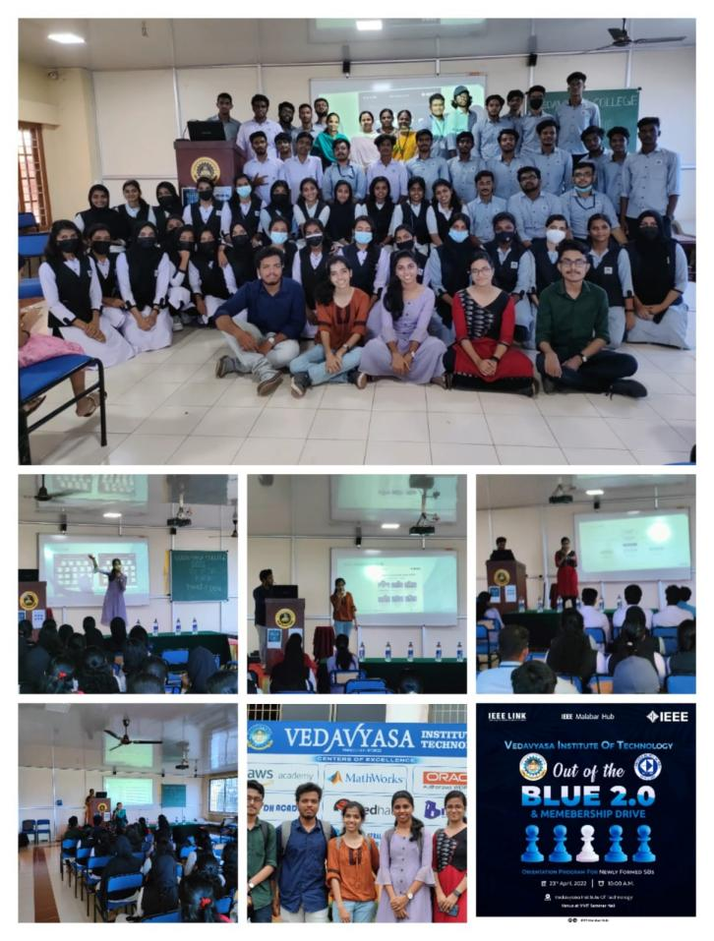
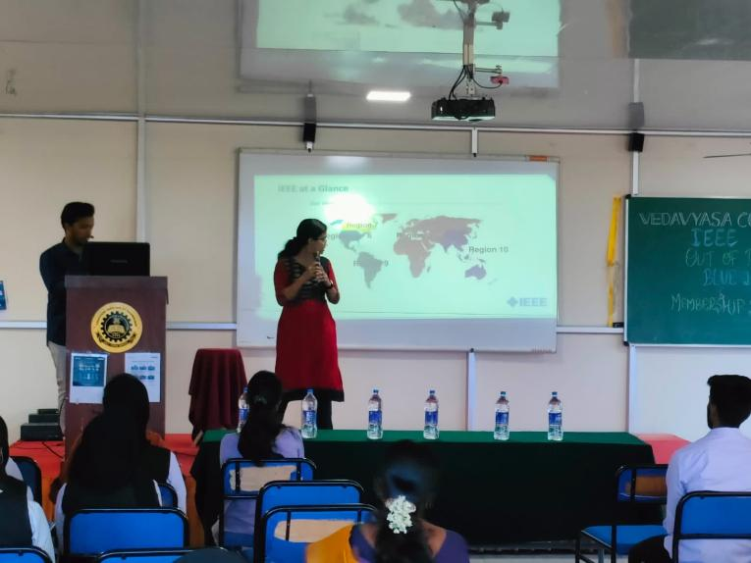

StudentBranch Execom training

An exclusive training session was hosted for the IEEE SB VVIT Students on 19/7/2022 led by Mr. Shone Jose, Vice chairman- Student Activities Committee, IEEE Kerala section, through Online. Students were able to understand their duties and responsibilities as an ExeCom member and develop ideas about how to strengthen the student branch.

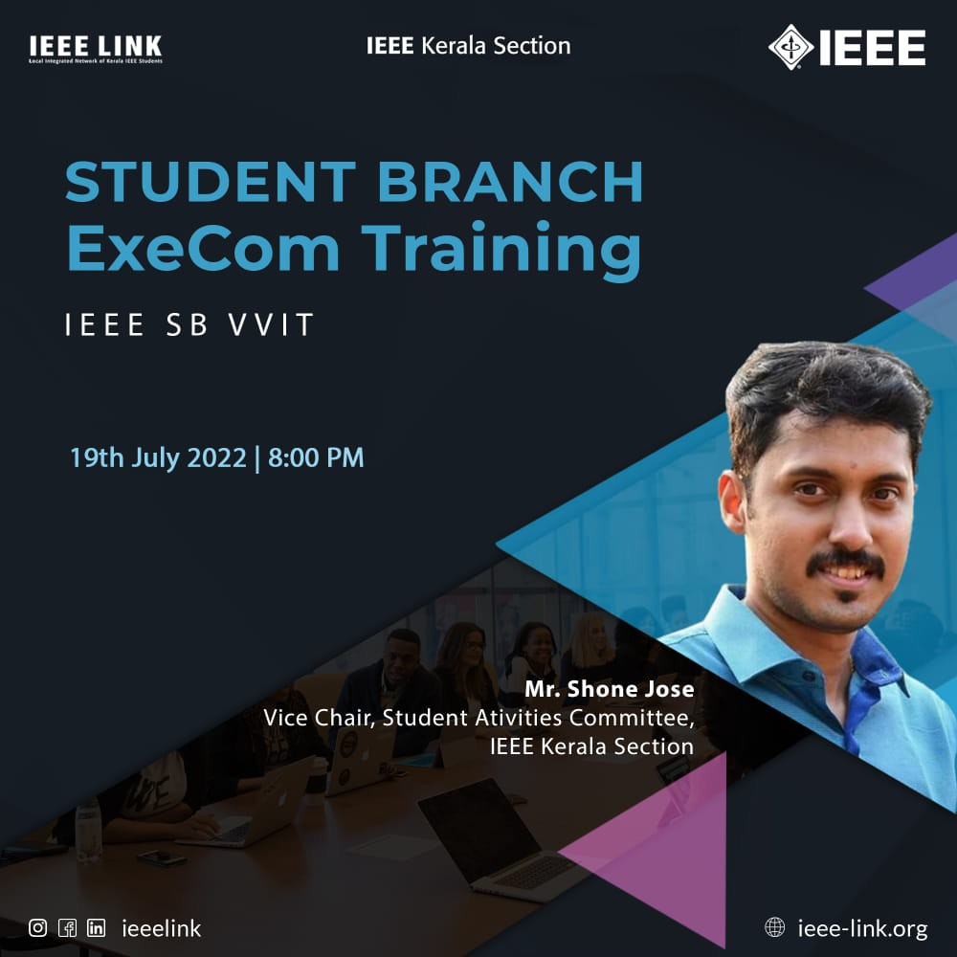

StudentBranch Execom training

Another exclusive training session was hosted for the IEEE SB VVIT Students on 03/8/2022 led by Prof Josna VR, Vice chairman- Student Activities Committee, IEEE Kerala section, through Online. Students were able to understand their duties and responsibilities as an ExeCom member and develop ideas about how to strengthen the student branch.

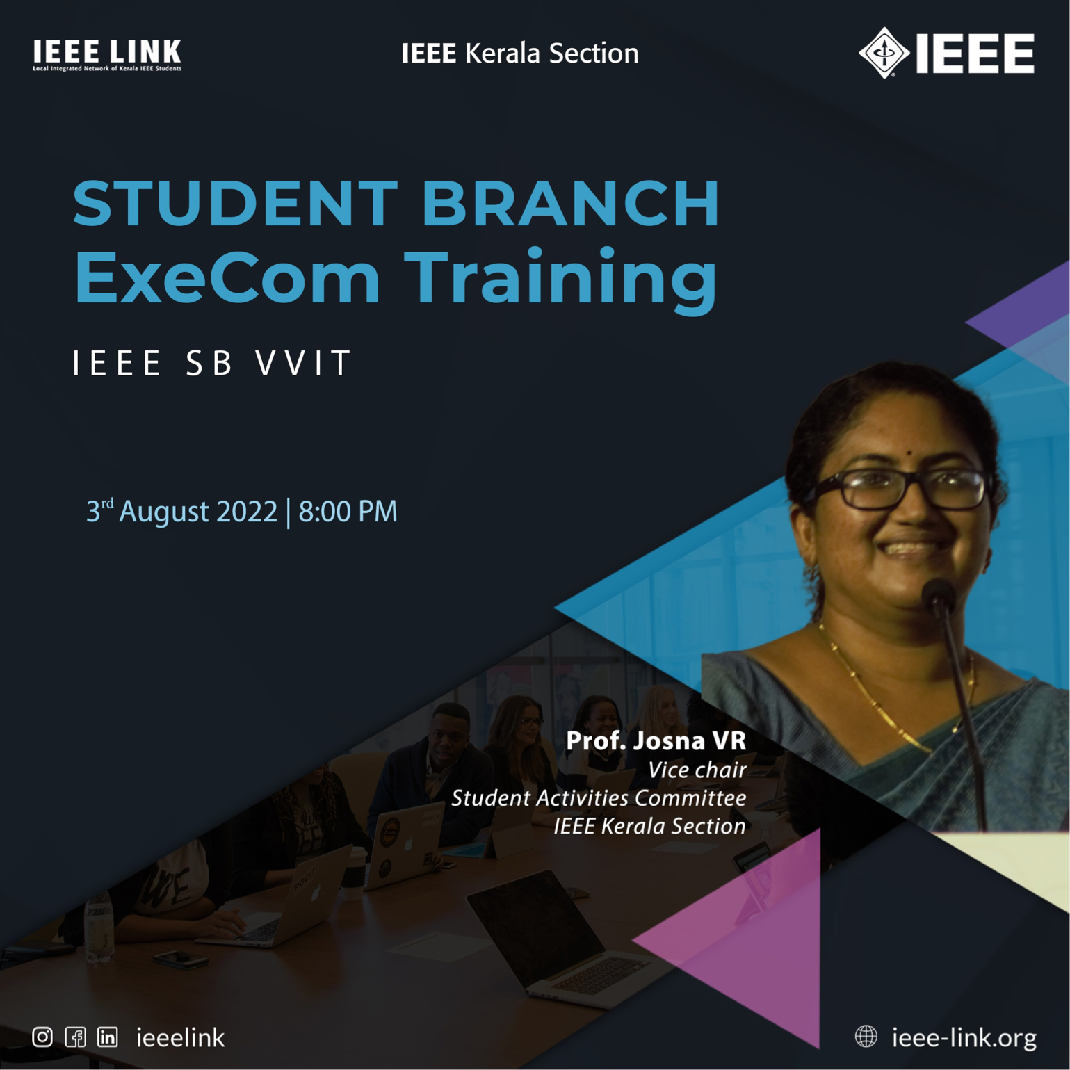

WORKSHOP ON HACK OR GET HACKED

A stage 1 Workshop was conducted by the IEEE SB VVIT on “Hack or get hacked” from vvit seminar hall on 28 october 2022.

