Vedavyasa Institute of Technology, Karadparamba
C-Code Competition
Program: Value added course | Title of activity: C- CODE CHEF
Organizer: ACM and Department of CSE, VVIT | Name of coordinators:  Dr.S.Kavitha Murugesan, Ms. Silpa A K  Ms. Fasna K, Ms Sruthi C K | Date: 30/09/2022  10:am to 01:00 pm
Summary of activity
One day Coding Competition in C language was organized by CSE Department on 30th September 2022, at Vedavyasa Institute of Technology, Karad, Malappuram. The Coding Competition is organized for third semester CSE students. 30 students from CSE department is participated in this section.These students sre divided in to 10 groups having 3 students in each group.Each group selected separate topic for coding. The main aim of this section is to know the coding ability of the students and to improve the coding to improve their ability to do great project work. All these 10 groups competed with others with their maximum effort. Winners are selected on the basis of good quality project and their completing time.Two groups are selected as winners from this 10 groups and gave attractive prizes for them. The overall section was interesting.
Benefit to /students :
- Improving the programming ability of the students.
- Typing speed increased.

No of participants: 30 (Students S3 B.Tech and Faculty)
Assessment/remarks of participants:
Very good informative session
The above mentioned activity was scheduled in accordance with the requirement of APJ Abdul Kalam Technological University to provide opportunity to earn activity points. The activity was a fair, ending with good success.

Signature of Coordinator
Documents accompanying:

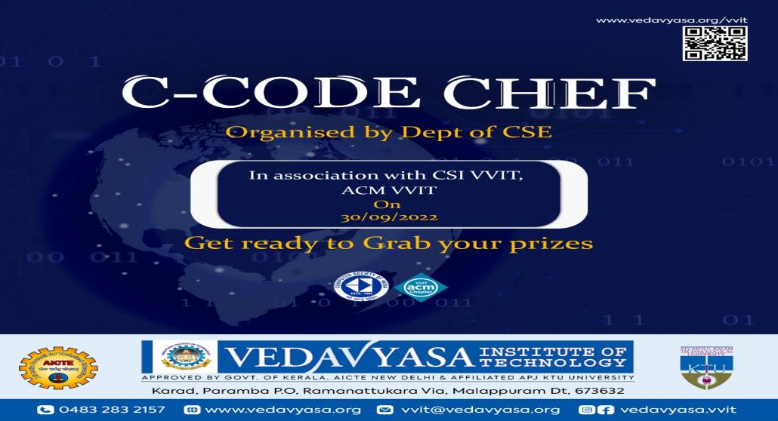

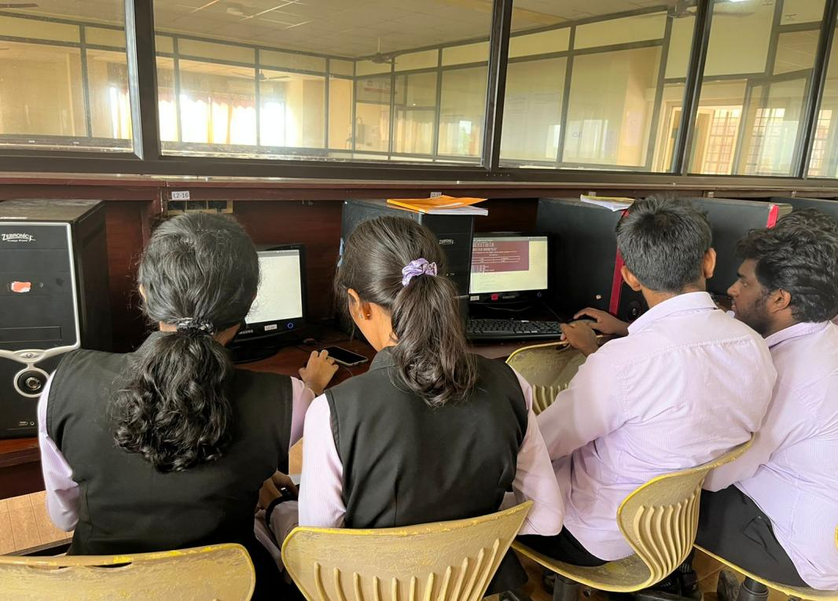

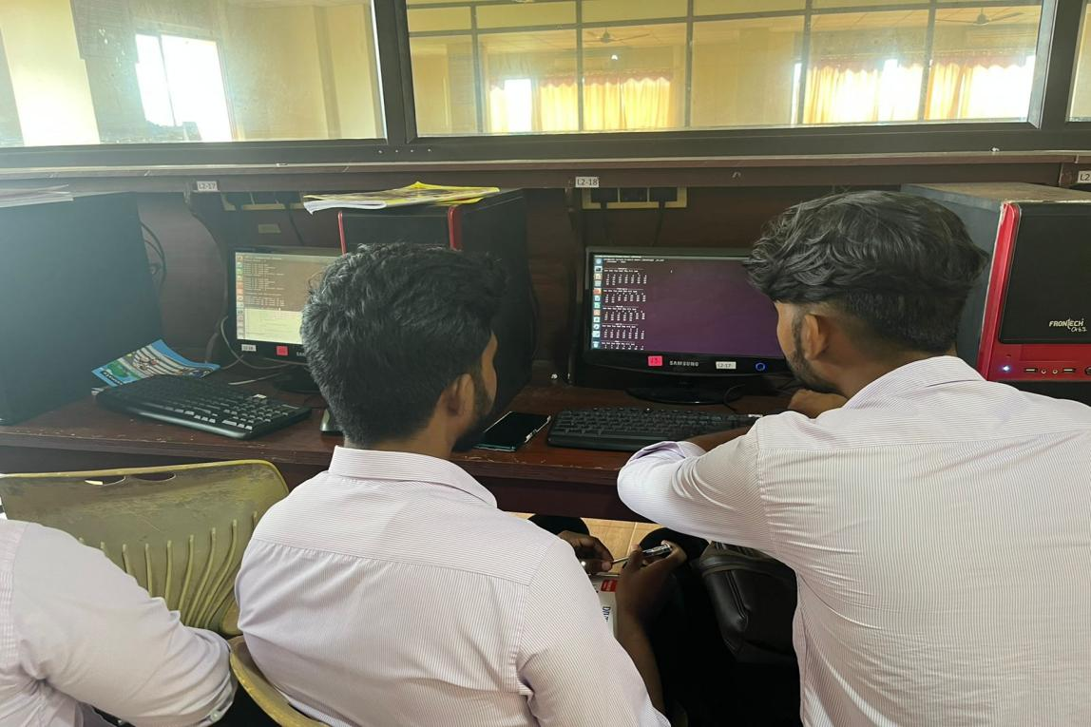

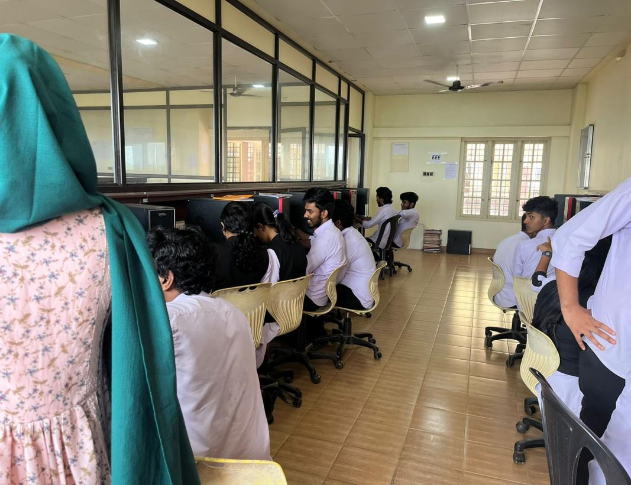
The activity was conducted during this semester and has given good benefits to student participants.

Dr.S.Kavitha Murugesan
HOD, CSE
Date

