NSS REPORT
Anti-Drug Campaign
VEDAVYASA INSTITUTE OF TECHNOLOGY

Anti-Drug Quiz
11-10-2022 (02:00 PM)

NSS (Unit No 601) Vedavyasa conducted an Anti-Drug Quiz on 11-10-2022. A total of 30 students were participated in the program. The quiz was conducted to encourage the students to gain knowledge about the anti-drug campaign that is going on throughout Kerala and to make students aware of the importance saving the youth from this great disaster. The programme was co-ordinated by the NSS programme officer, Vedavyasa Institute of Technology. The panel of judges includes Asst Professor Kiran Murali (ME Department), Asst Professor Abhiram (ME Department). Third year NSS volunteers helped in the transparent running of the program.
Winners
- Vyshnav Vinod (S3 Civil)
- Kaushik (S3 Civil)
- Mridun C.T (S3 Civil)
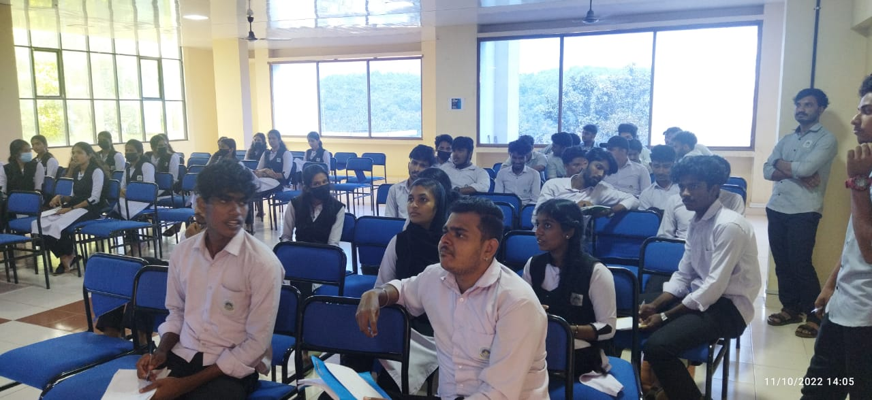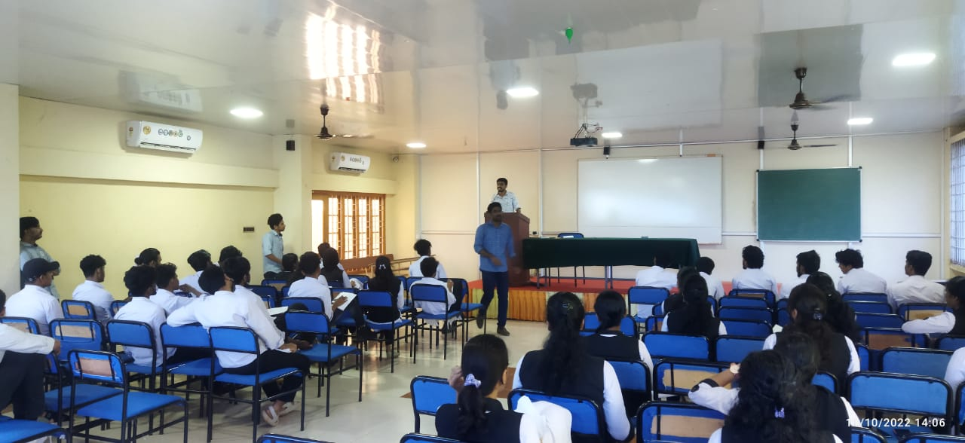
Anti-Drug Awareness Seminar
12-10-2022 (10:00 AM)

NSS unit 601 of Vedavyasa institute has conducted an anti-drug awareness seminar on 12-10-2022. The programme began with prayer song sung by the students. The programme is presided by Dr. Periyaswami (HOD of Electronics and communication department). NSS programme officer welcomed all the dignitaries present, colleagues and students. The programme was inaugurated by our honourable panchayath president Sri. Vasudevan Master. Our chief guest of honors Sri Suresh kumar K (SI, Vazhayur Police Station) and Smt. Zilla (Excise Officer, Kondotty) stressed the importance of educating students about the negative sides of illegal drugs and eradicating the drug mafia by its roots. Sri, Narayanan Thannani felicitated the program. Sri Balakrishna Pillai (HOD of EEE department) offered vote of thanks to all.

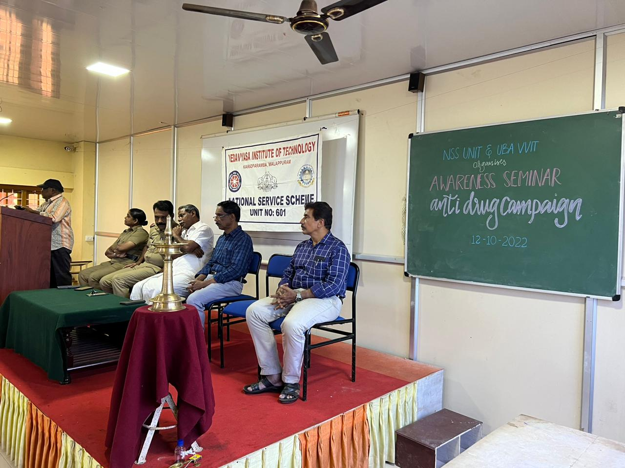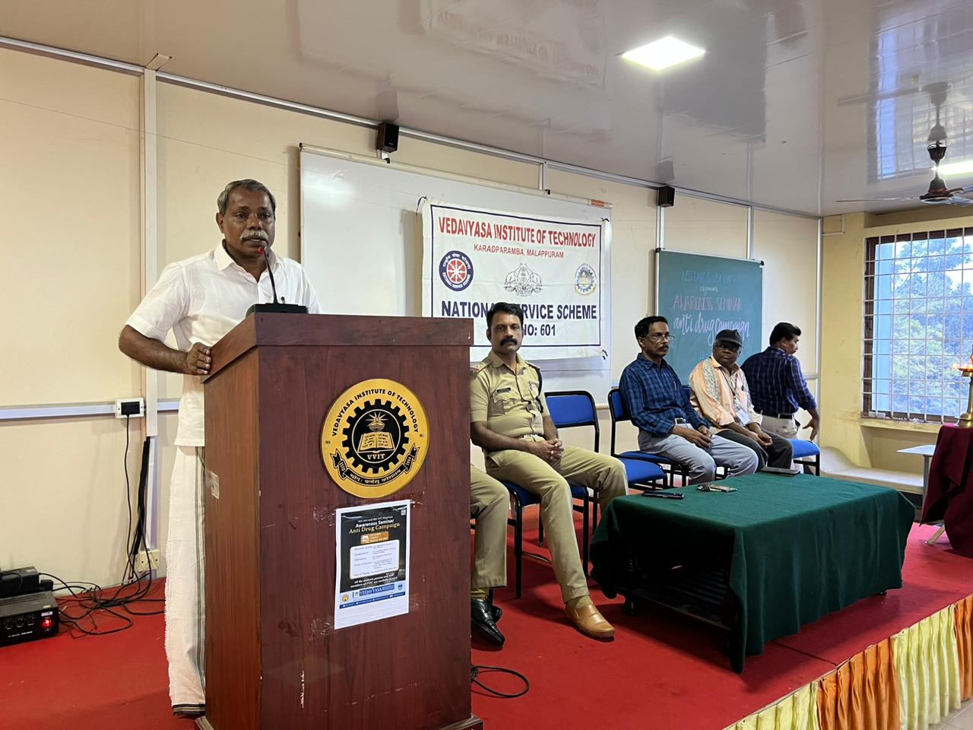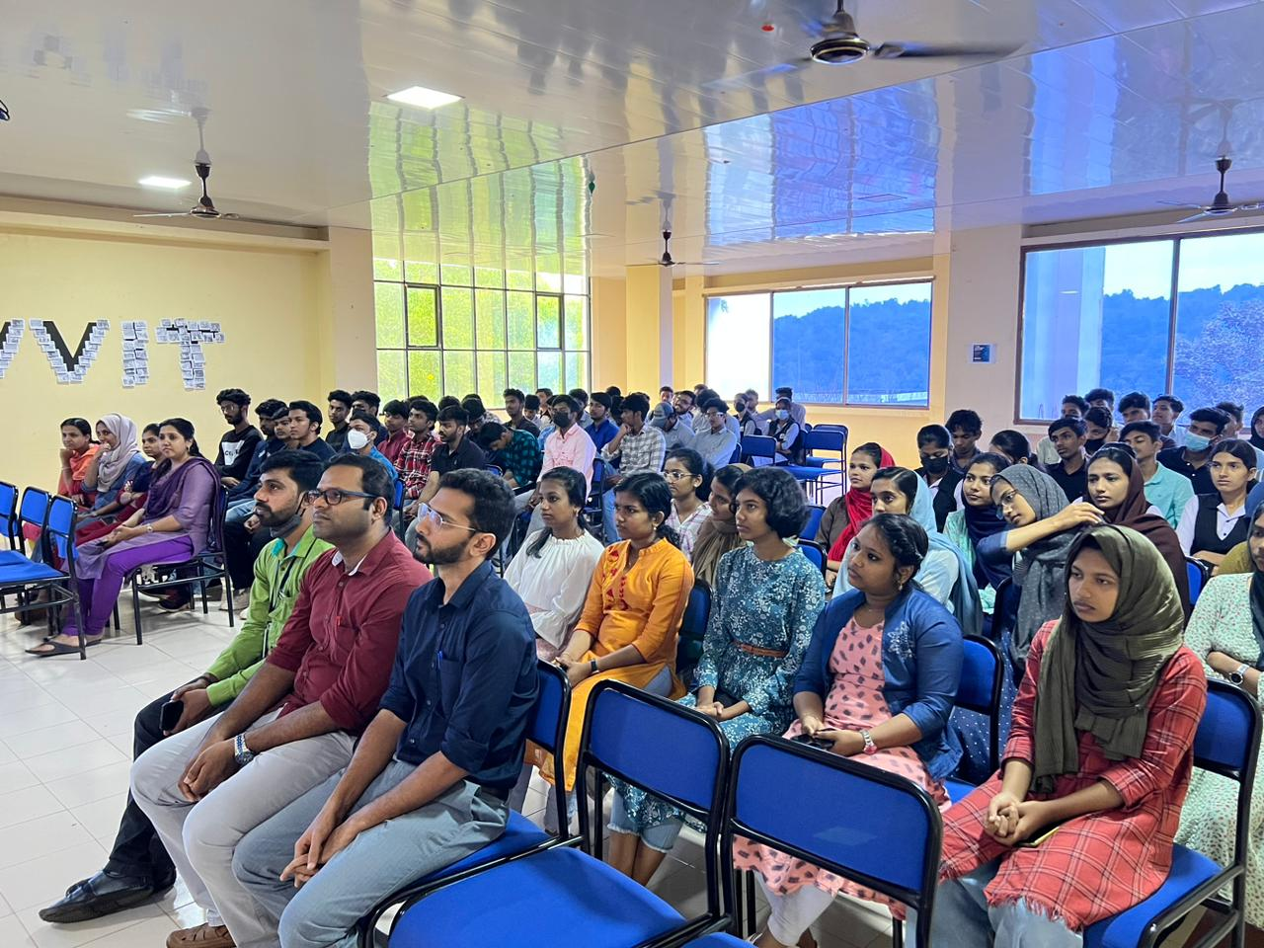

Anti-Drug Rally
12-10-2022 (03:00 PM)

NSS (Unit 601) has conducted a student march as a part of the “No to drugs” campaign. Students were marched from karad junction to Vazhayur Panchayath office holding placards against drug and drug mafia. They conveyed a strong message to the society that we, the students of vedavyasa, will fight tooth and nail against the ruthless drug mafia.
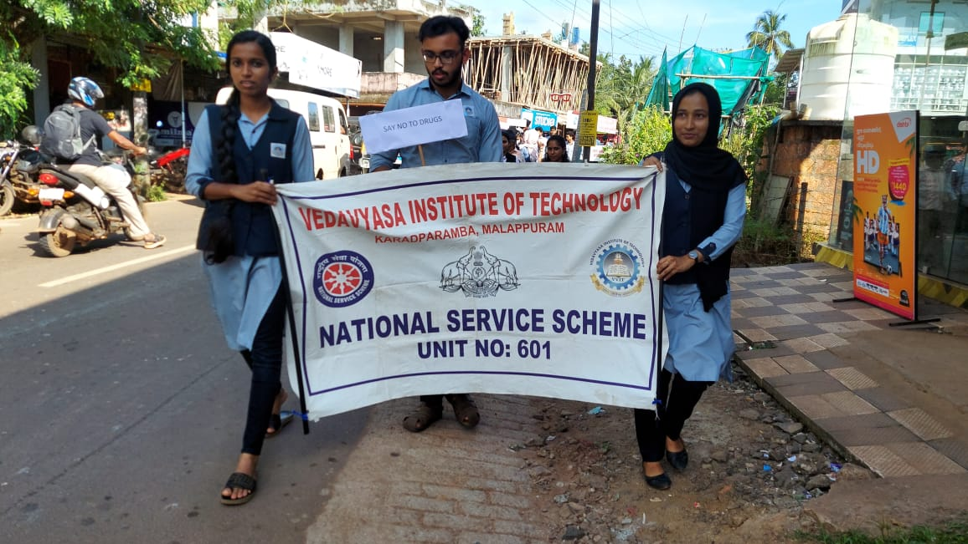
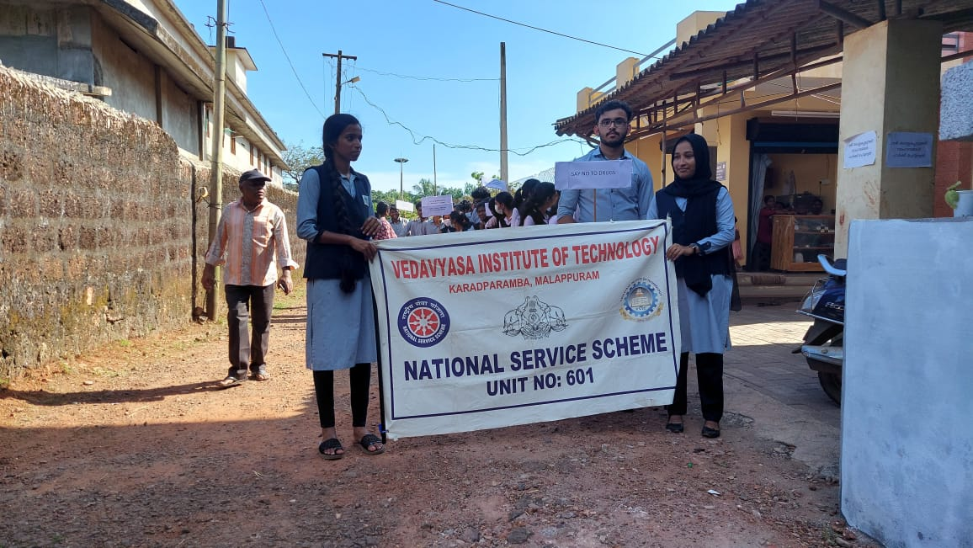
Anti-Drug Marathon
12-10-2022 (10:00 AM)
NSS at Vedavyasa Institute of technology participated in the “Koottayottam” conducted by Vazhayur panchayath. The program was split into two regions, in which our students represented the West Vazhayur region. West region was flagged off by Smt. Mini Kolethodi (Vice president, Vazhayur panchayath). The running started from laksham veed and ended at karad main ground.
