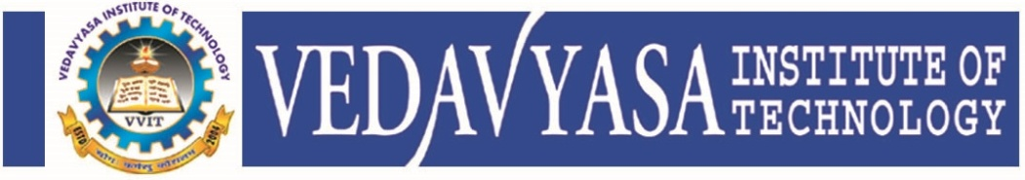
Institution’s Innovation council
IIC Activity Report
Program:  Webinar | Title of activity:  Session on “Entrepreneurship and Innovation as Career Opportunity”
Organizer:  Institution's Innovation Council (IIC) VVIT | Name of coordinators:  Dr. Periasamy.C  President II Council, VVIT | Date: 29.10.2021
Summary of activity:
The presentation covered much needed Innovations in the emerging fields like Agriculture, Health Care, Rural Development, Services and Social welfare in India. Success stories of An Inspiring Self-Powered Odanthurai Village, Reuse of waste plastic for road laying, Use of cattles for converting vegetable waste into usable product in a short span of time, first drone powered flying passenger car by an Indian Startup firm were presented. A small innovation with cash prize also was offered to the audience. The session ended with feedback
Benefit to faculty/students:
- Practical engineering skills
- Knowledge acquisition
- Familiarity with real-world
- Decision Making skills as a leader

No of participants: 106 ( 81 Students and 25 Faculty)
Assessment/remarks of participants:

The webinar session is very nice and informative session. Some participants give appreciation as excellent.
Name, designation of external resource person:

Er. Ramasamy Muruga Mudaliar B E (Mech Eng)
Vice president
QDT Technology
Bangalore

The above mentioned activity was scheduled in accordance with the requirement of APJ Abdul Kalam Technological University to provide opportunity to earn activity points. The activity was informative with rate of good success

Signature of Coordinator

Documents accompanying:
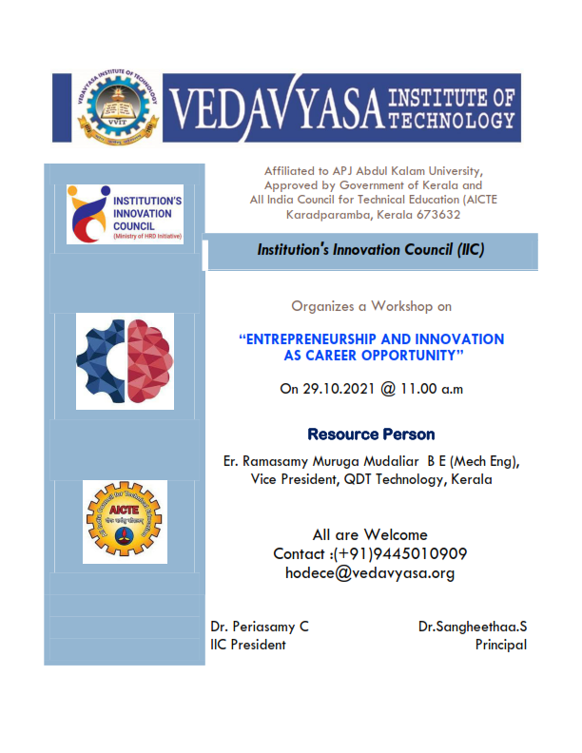
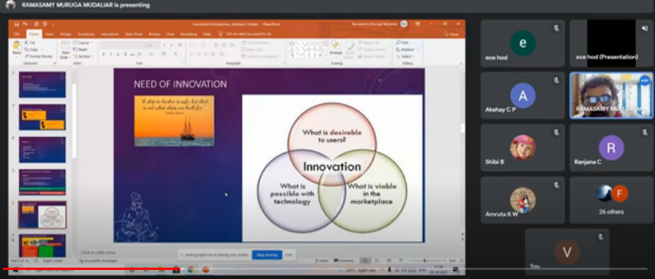
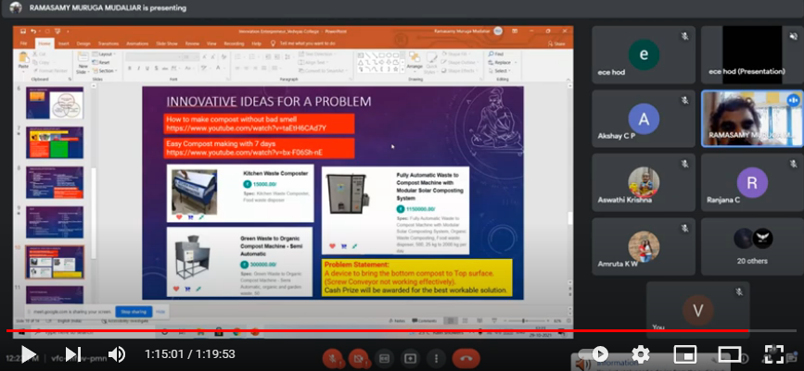
The activity was conducted during this semester and has given added benefits to student and faculty participants.

Dr S. Sangheethaa
Principal
Date 13.10.21

