Vedavyasa Institute of Technology, Karadparamba
Institution’s Innovation council - Activity Report
Program: Entrepreneurship Development Programme | Title of activity:  Workshop on “Intellectual Property Rights and  IP management for Startup”
Organizer:  Institution’s Innovation council - VVIT | Name of coordinators:  Dr.C.Periasamy II C president  Dr Kavitha Murugesan HOD CSE | Date: 30.06.2021
Summary of activity:
Intellectual property is a product of human intellect and the rights granted on it allow its owner to benefit from the fruits of this intellectual endeavour by creating a monopoly over it.
According to Trade Related Aspects of Intellectual Property Rights (TRIPS), the intellectual property rights are:
1) Copyright and Related Rights
Rights of artists, painters, musicians sculptors, photographers, and authors for copyright in their works; Rights of computer programmes whether in source or object code for a copyright in their programmes and compilation data; Rights of performers producers of phonogram’s and broadcasting organizations in respect of fixation on their programmes for copyright in their work.
2) Right of traders in their trade marks.
3) Right of manufacturers & producers on geographical indication in relation to such products
and produce.
4) Right of designers for their distinctive design striking to the eye.
5) Patents:
Right of the inventor for patent is his invention; Rights of plant breeders and farmers; Rights of biological diversity.
6) Right of computer technologist for their layout design of integrated circuits.
7) Right of businessmen for protection of their undisclosed information on technology and management.

Benefit to faculty/students:
- Practical engineering skills
- Knowledge acquisition
- Familiarity with real-world
- Decision Making skills as a leader

No of participants: 53 (Students and Faculty)
Assessment/remarks of participants:
The session provided informative and most helpful tips about IPRs and IP management to engineering teachers/faculty .
Name, designation of external resource person:
Mr. T.Narayanan

Administrative Officer Vedavyasa Institute of Technology

The above mentioned activity was scheduled in accordance with the requirement of APJ Abdul Kalam Technological University to provide opportunity to earn activity points. The activity was informative with rate of good success

Signature of Coordinator
Documents accompanying:
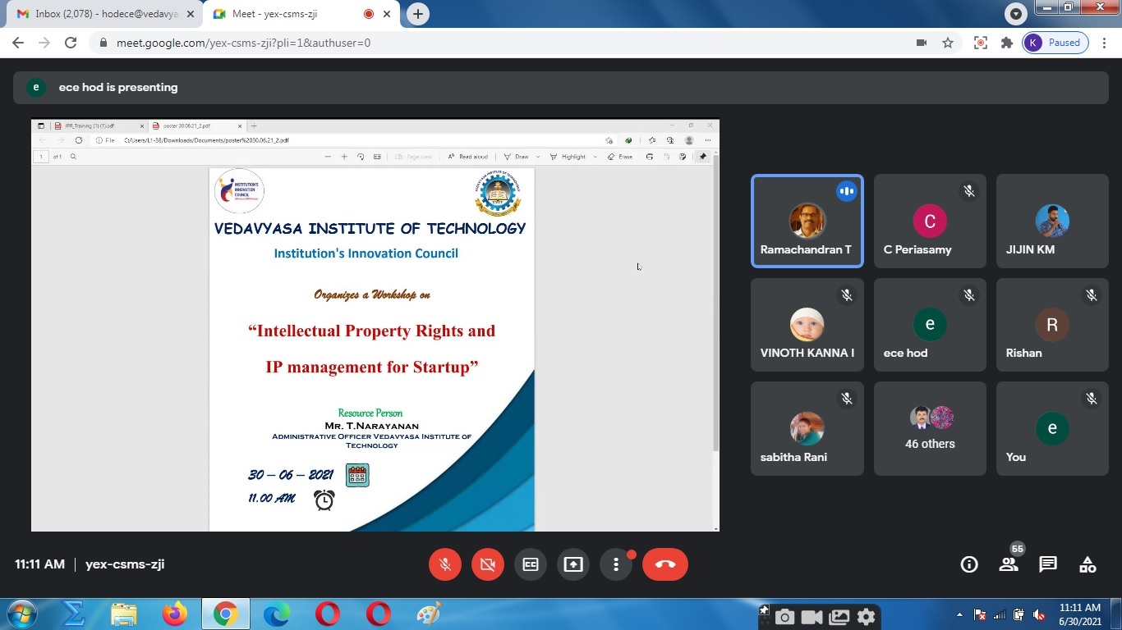
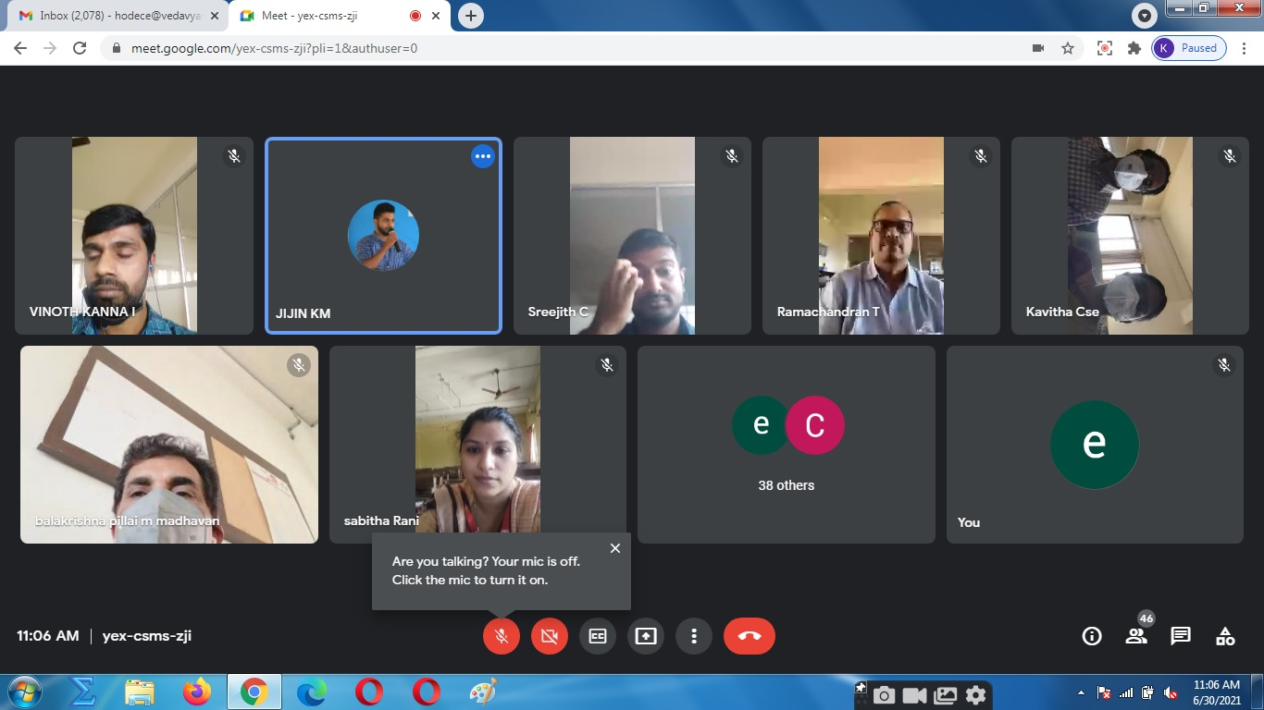
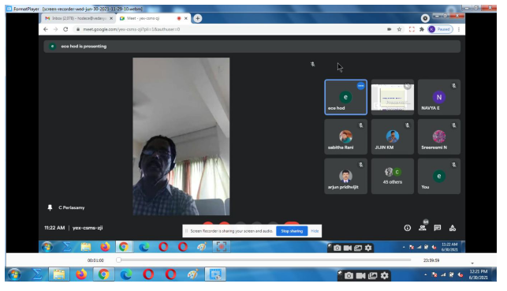
The activity was conducted during this semester and has given added benefits to student and faculty participants.

Dr S. Sangheethaa
Principal
Date 30.06.21

