Institution’s Innovation council
Activity Report
IIC 4 Sem 1- Innovation Ambassador Activity
Program:  Innovation Ambassador Activity | Title of activity:  “Challenges and Scope in Innovations”
Organizer:  The Institution’s Innovation Council (IIC) | Name of coordinators:  Mr. Vinoth Kanna I  Assistant Professor – Mechanical Engineering – VVIT | Date: 04/02/2022  Time : 02.00 pm  Venue: Online
Name, designation of resource person:
Dr Periasamy C
IIC President-VVIT
Summary of activity:
This session started with the welcome address by Mr. Vinoth Kanna I,
The session covered the following Challenges.
- Innovation strategy lacking from the outset
- Agile transformation coming first (hoping to magically fix everything)
- Managerial support urgency for radical innovation
- Need for disruptive business model innovation capabilities
- New business creation and support in structuring the organization
- A gap between knowing what to do and actually doing it
- Shift towards beginning and end stages of the innovation funnel
To overcome that challenges, companies need to become “serial innovators,” developing the capacity to engage in multiple fast-paced experiments
The presentation was supported by feedback and discussions.
Benefit to faculty/students are Practical engineering skills and Decision Making skills as a leader

No of participants: 23 (15 Students and 8Faculty)
Assessment/remarks of participants:
It was a fair session. It is really helpful and awesome that gives us an idea how to focus on innovations

Documents accompanying: Snapshots of the session, poster
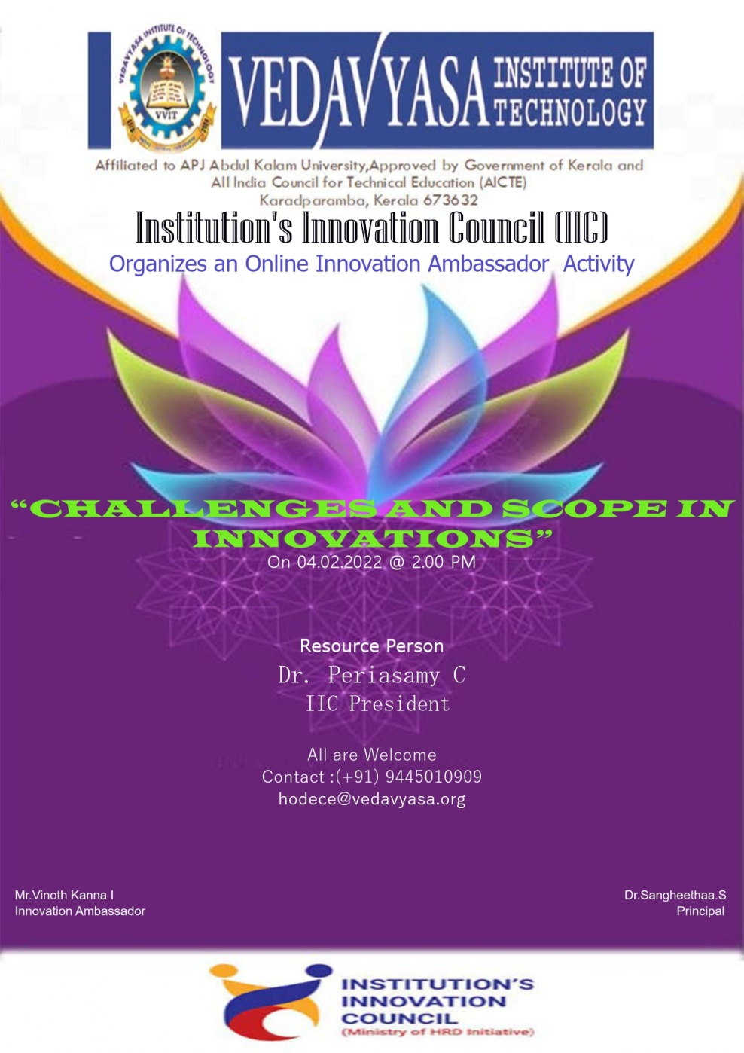
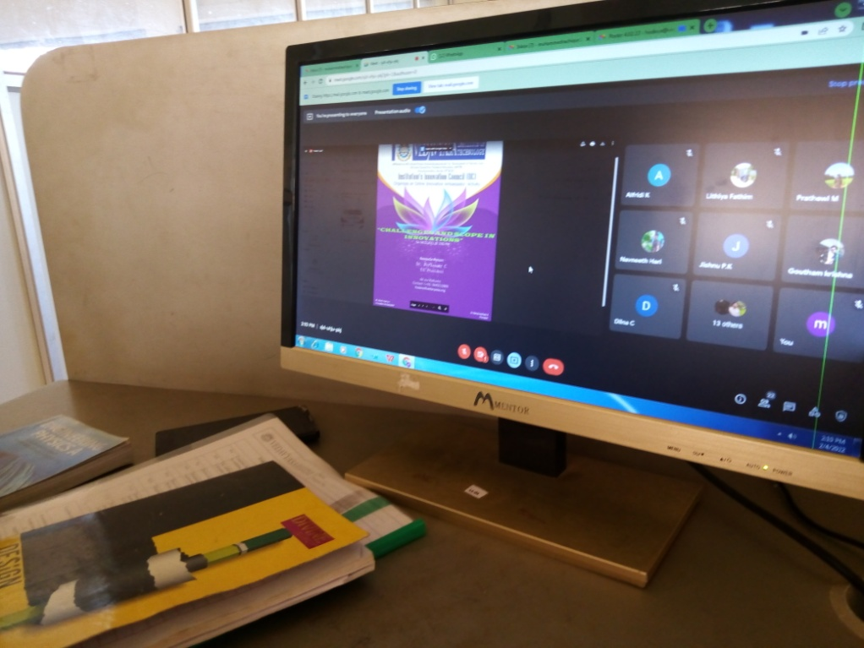
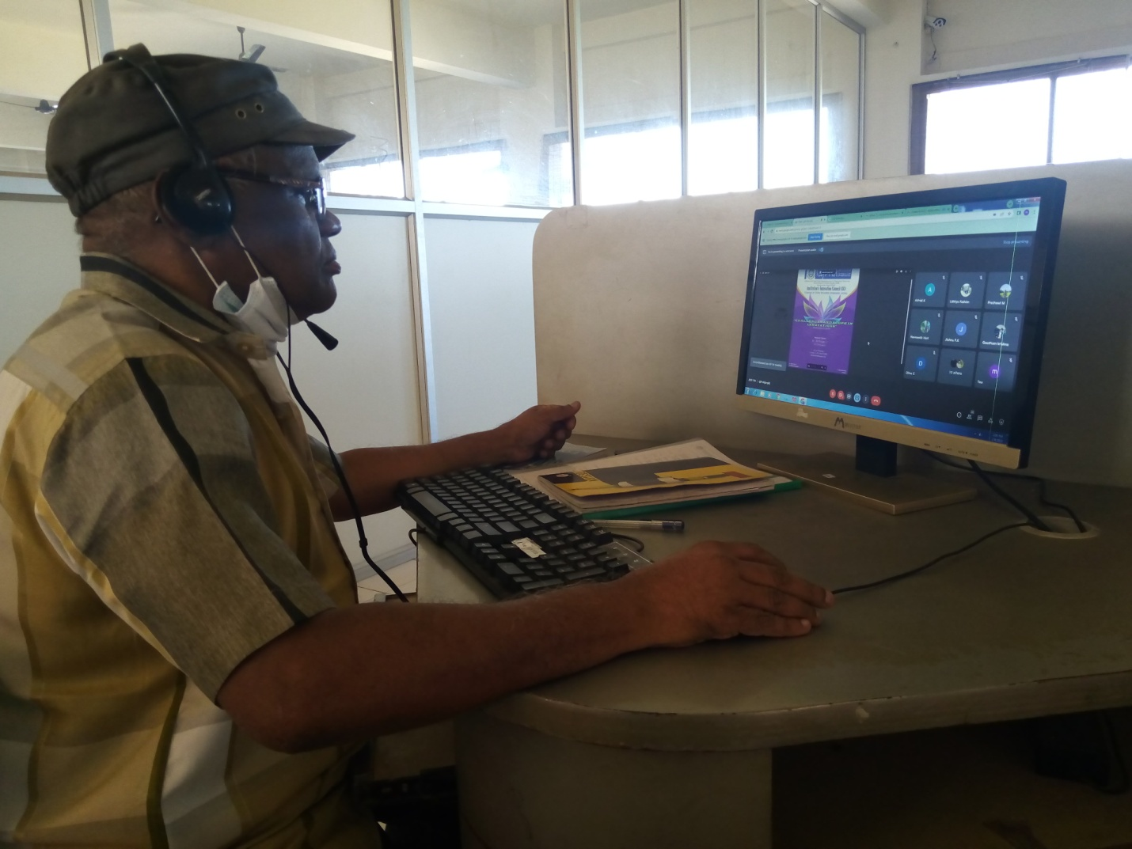
The activity was conducted during this semester and has given added benefits to student and faculty participants.
Dr S. Sangheethaa
Principal
Date 04.02.21

