Vedavyasa Institute of Technology, Karadparamba
Industrial Institute Interaction Cell - Activity Report
Program: Entrepreneurship Development Programme | Title of activity:  Session on “Accelerators/Incubation-Opportunities for Students & Faculty Early Stage Entrepreneurs”
Organizer:  II C- VVIT | Name of coordinators:  Dr.C.Periasamy II C president  Dr Kavitha Murugesan HOD CSE | Date: 18.06.2021
Summary of activity:
A business accelerator is a program that gives developing companies access to mentorship, investors and other support that help them become stable, self-sufficient businesses. Business Incubation is the name given to the process, wherein an individual or an organization supports the establishment and growth of a start-up. The funding opportunities for Students & Faculty were discussed. The early stage company faces numerous challenges in this stage. The company is new and it does not have ample resources to cover its operational and other related activities. Because of the lack of credit history and demonstrable revenue, traditional means of borrowing is generally out of the question. For this reason, early-stage ventures often depend upon investors to fund the business growth.
Benefit to faculty/students:
- Practical engineering skills
- Knowledge acquisition
- Familiarity with real-world
- Decision Making skills as a leader

No of participants: 101 (Students and Faculty)
Assessment/remarks of participants:
The session provided good innovative sustainable solutions. It was very informative
Name, designation of external resource person:
Ms Saritha Riju
CEO, SEAOUX Imports & Exports (P) Ltd,Calicut
The abovementioned activity was scheduled in accordance with the requirement of APJ Abdul Kalam Technological University to provide opportunity to earn activity points. The activity was informative with rate of good success

Signature of Coordinator
Documents accompanying:
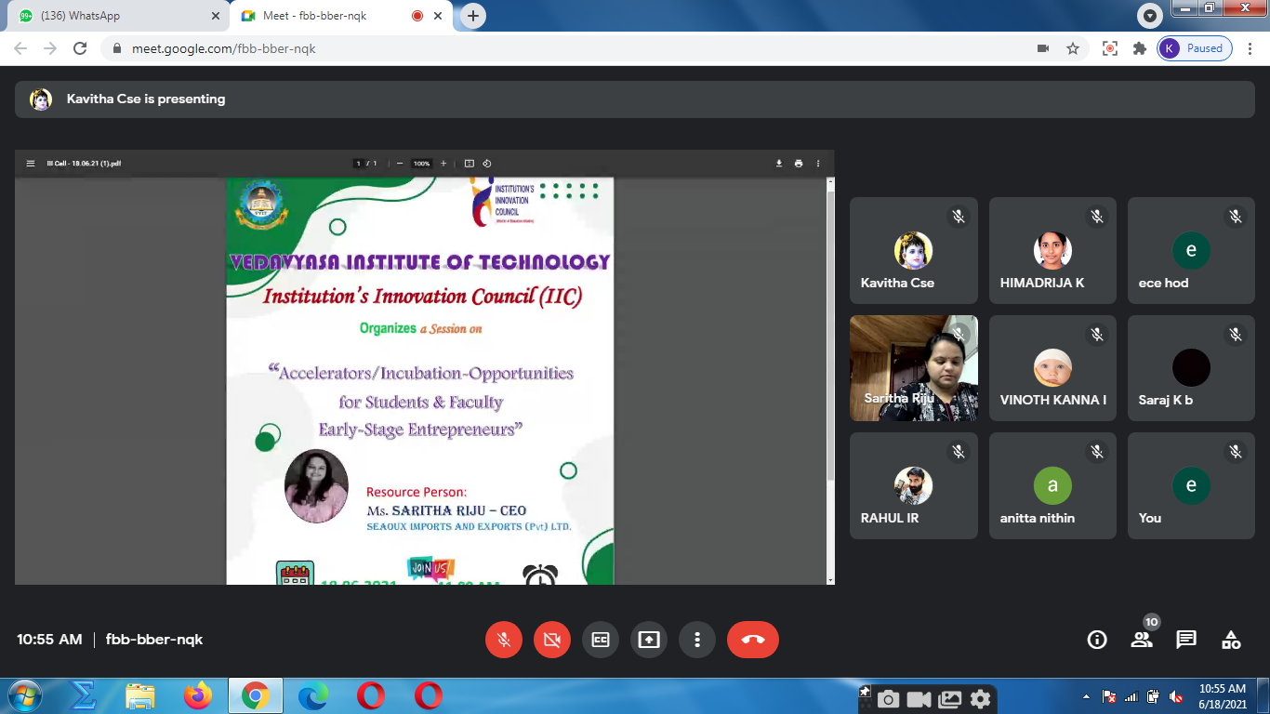
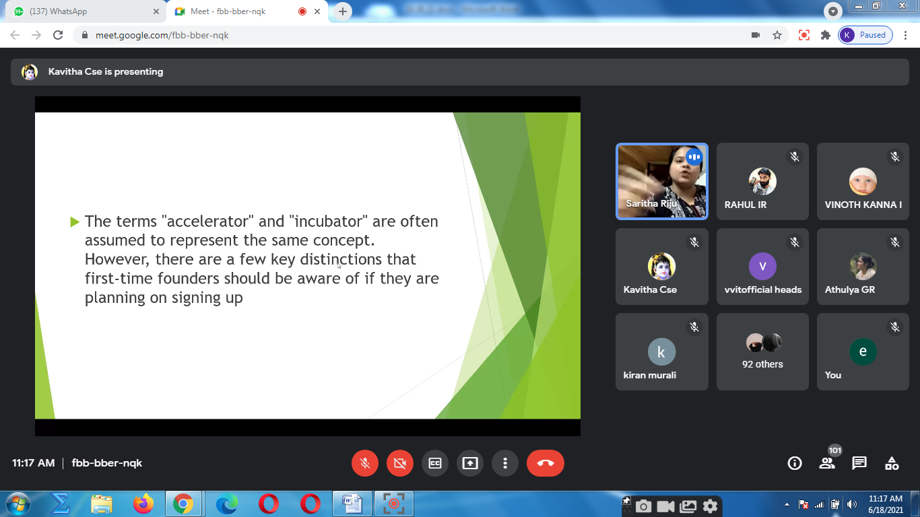
The activity was conducted during this semester and has given added benefits to student and faculty participants.

Dr S. Sangheethaa
Principal
Date

