Institution’s Innovation council
Activity Report
IIC 4 Sem 1- Q2- MIC Driven Activity
Program:  MIC Driven Activity | Title of activity:  Orientation session on Institution Innovation Council (IIC) 4.0
Organizer:  The Institution’s Innovation Council (IIC) | Name of coordinators:  Dr. C. Periasamy, President, IIC | Date: 24/01/2022  Time : 2.30 pM – 4.30 PM  Venue: MOE - Online
Name, designation of resource person:
- MIC Driven Dignitaries
Summary of activity:
The session discuss the IIC 4 features as follows
- Enabling IIC Institute To check progress of Innovations received funding assistance from MIC and AICTE
- Integration of Innovation Ambassador portal with IIC –Institute
- Check eligibility and participate in Schemes and programs
- Mentor-Mentee prescribed Activity and progress monitoring
- IIC Institutions to link with Atal Tinkering Labs in Schools
- E-Learning repository Builup and resource Utilization
- IIC Institute level repository of ideas innovations and startups
- Building IIC subnetworks : Coordination and integration of University and Institute : Engaging , Tracking and managing.
- Refer New institute and Earn Credit Point towards 5th star

Benefit
This Program is benefited for the faculty, students and alumni of the institution. as explained below
- IIC 4.0 Registration and Participation Guidelines
- Introduction to New Features of IIC 4.0 Portal and How to Use It.
- Glance through various programs and schemes for IIC institutions
- Incentives and measurement of performance IIC Institutions effort
- Integrated policy approach for maximum impact - NISP+IIC+ARIIA

No of participants: 25 (15 Students, 10 Faculty)
Assessment/remarks of participants:
It was a good session. The session was interesting and informative It is really helpful and awesome that gives us objectives and features of IIC 4

Documents accompanying: Snapshots of the session
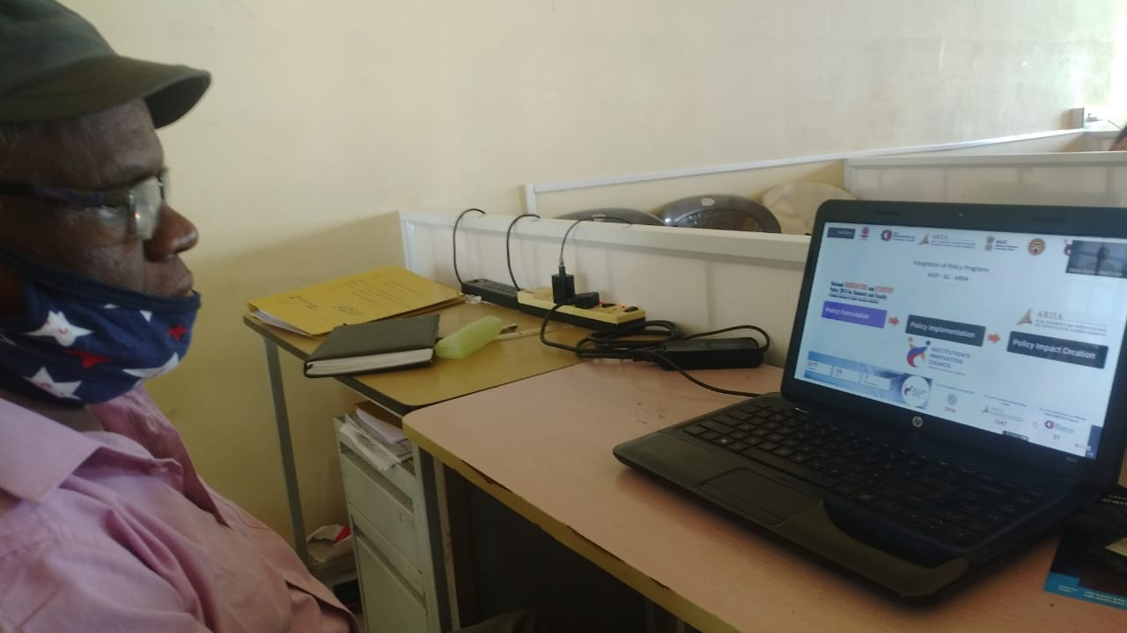

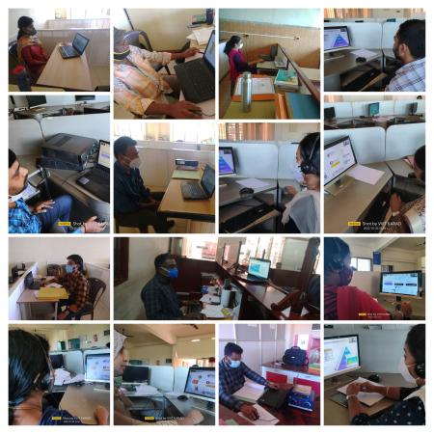

This activity was conducted by MOE and has given added benefits to student, alumni and faculty participants.
Dr S. Sangheethaa
Principal
Date 24.01.2022

