Institution’s Innovation council
Activity Report
IIC 4 Sem 1- Q2- Calendar Activity
Program:  IIC4 Calendar activity | Title of activity:  Workshop on Design Thinking, Critical thinking and Innovation Design
Organizer:  The Institution’s Innovation Council (IIC) | Name of coordinators:  Dr Periasamy C  IIC President | Date & duration  30.01.2022&  2 Hour
Name, designation of resource person:
Mr. Vinoth kanna I – Associate Professor – Mech – VVIT.
Summary of activity:
On 30thof January, 2022 Institute Innovation Council Cell conducted a workshop titled “Workshop on Design Thinking, Critical Thinkingand Innovation Design”. The guest speaker for the event was our innovation ambassador Mr. Vinoth kanna I – Associate Professor- Mech. He spoke about innovation and creative thinking to the students who aspire to start their ownventures. He insisted on continuous critical thinking on products and adapt to the needs of thecustomers. 46 student and 11 faculty enthusiasts were present online and they were highly motivated with the approaches being discussed by the speaker. The students were given e-Certificates for their participation. The session ended with vote of thanks..
Benefit to faculty/students:
- Knowledge acquisition
- Decision Making skills as a leader

No of participants: 57(46Students and 11Faculty)
Assessment/remarks of participants:
All students and faculty of the institution to gain knowledge of Design Thinking, Critical Thinking and Innovation Design. They came with the idea after this workshop as “Innovation with design thinking demands critical thinking because we must understand our assumptions that frame our ideas and shape our design.Critical thinking does not hinder–but rather augments–innovative thinking”.

Documents accompanying: Snapshots of the session, poster
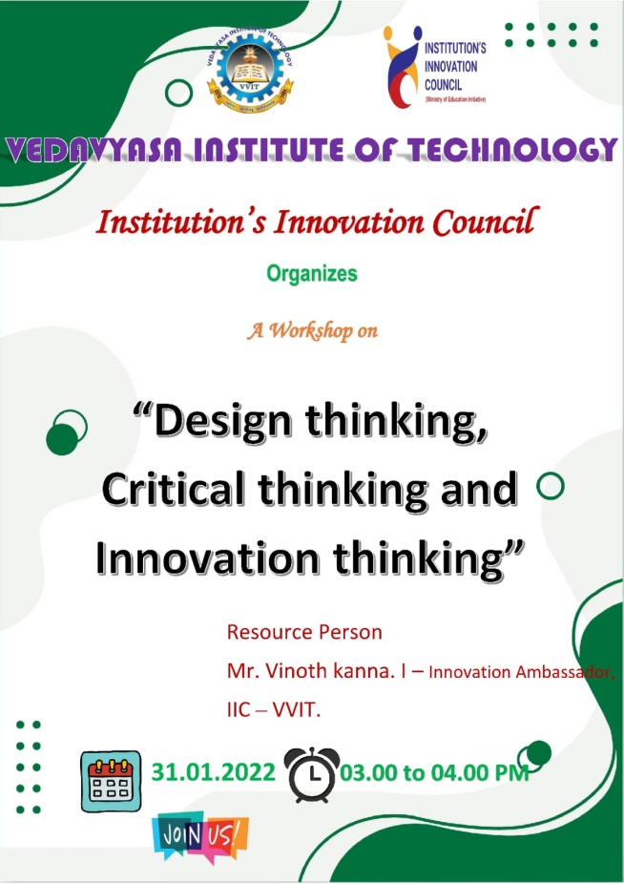
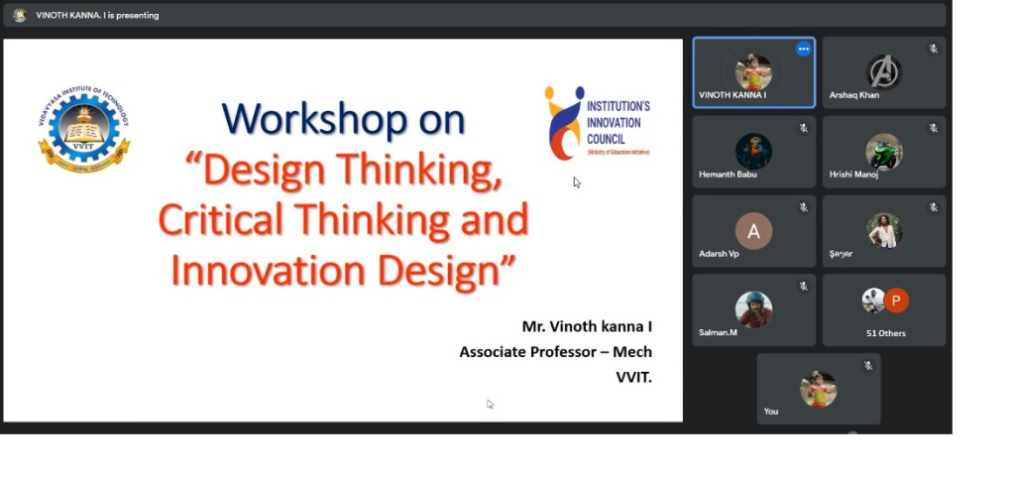
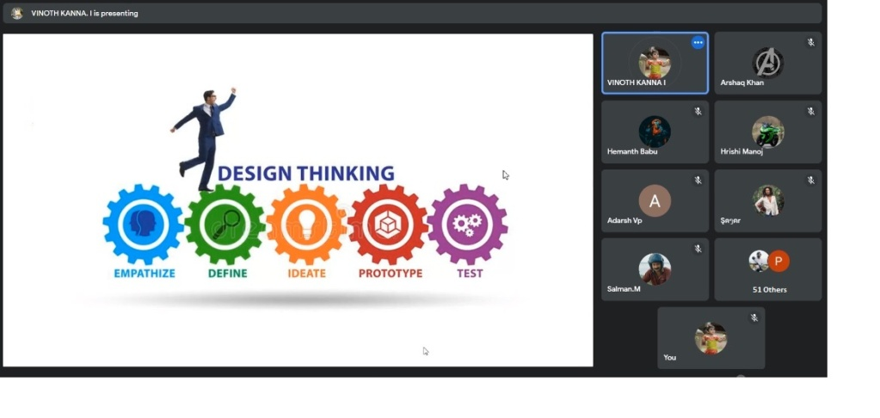
The abovementioned activity was schedule in accordance with the requirement of APJ Abdul Kalam Technological University to provide opportunity to earn activity points. The activity was a fair
Dr S. Sangheethaa
Principal
Date 31.01.22

