Vedavyasa Institute of Technology, Karadparamba
Industrial Institute Interaction Cell - Activity Report
Program: Entrepreneurship Development Programme | Title of activity:  Workshop on “Prototype/ process design and development- prototype”
Organizer:  III Cell- VVIT | Name of coordinator:  Dr.C.Periasamy III Cell president | Date: 16.06.2021
Summary of activity:
The process design and development is a sequence of all the required activities.These activities include marketing, research, engineering design, quality assurance, manufacturing, and a whole chain of suppliers and vendors. A prototype is an early sample, model, or release of a product , built to test a concept or process. The benefits are flexible in design, scope of refinement and ideal for online system, etc., The challenges are poor documentation, variation in requirements and uncertainty in determining the number of iterations. Successful prototyping identifies and corrects problems long before they can negatively impact and irreparably harm the final finished project
Benefit to faculty/students:
- Practical engineering skills
- Knowledge acquisition
- Familiarity with real-world
- Decision Making skills as a leader

No of participants: 58 (Students and Faculty)
Assessment/remarks of participants:
The session was nice and informative with enchanting words of the resource person
Name, designation of external resource person:
Dr Periasamy C , II C President
The abovementioned activity was scheduled in accordance with the requirement of APJ Abdul Kalam Technological University to provide opportunity to earn activity points. The activity was informative with rate of good success

Signature of Coordinator
Documents accompanying:
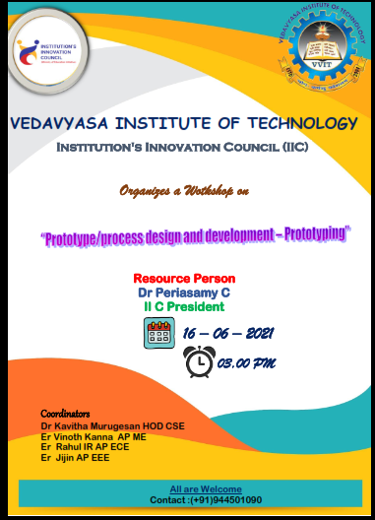
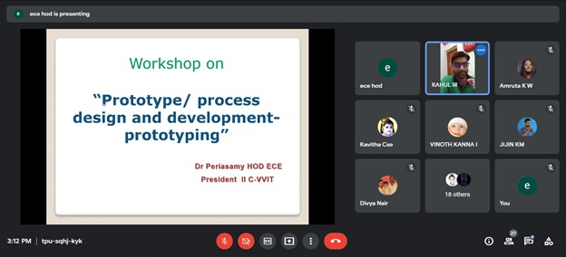
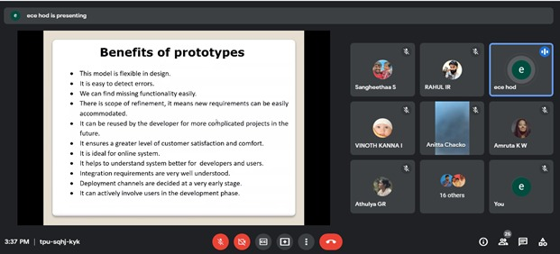
The activity was conducted during this semester and has given added benefits to student and faculty participants.

Dr S. Sangheethaa
Principal
Date

