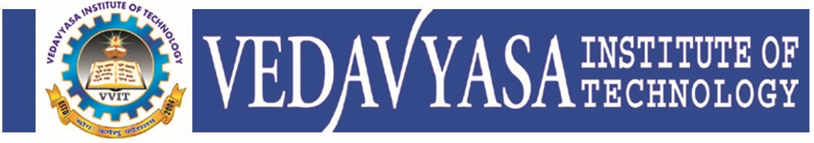
Institution’s Innovation council
Activity Report
IIC4 Sem 1- Q1 Activity
Program:  Session | Title of activity:  MY STORY A motivational Session by Successful Innovator or Entrepreneur.
Organizer:  The Institution’s Innovation Council (IIC) in association with EEE Dept., EnSav Club and CSI unit of VVIT | Name of coordinators:  Prof. Balakrishna Pillai President ENSAV Club  Dr. Kavitha Murugesan President CSI unit  Mr. Jijin K M Secretary Ensav Club | Date: 29/11/2021
Summary of activity:
This session starts with the welcome address by Ms. Haseena AP EEE and followed with the felicitations from Dr. Kavitha Murugesan and Dr. Periasamy C. The session covers the following points. 1.Quadupreneur, 2.Quality minds, 3.human energy, 4.self concept, 5.self esteem, 6.social self, 7.self knowledge,
The presentation was supported by feedback and discussions. The vote of thanks was delivered by Mr Jijin K M, IIC coordinator .
Benefit to faculty/students:
- Practical engineering skills
- Knowledge acquisition
- Familiarity with real-world
- Decision Making skills as a leader

No of participants: 59 ( 49 Students and 10 Faculty)
Assessment/remarks of participants:

It was a good session. The session was interesting and informative It is really helpful and awesome that gives us an idea how to achieve a success of Entrepreneur

Name, designation of external resource person:

Dr. Gupta K S
Director, Center for Quality Minds,
Bangalore
The above mentioned activity was scheduled in accordance with the requirement of APJ Abdul Kalam Technological University to provide opportunity to earn activity points. The activity was informative with rate of good success

Signature of Coordinator

Documents accompanying:
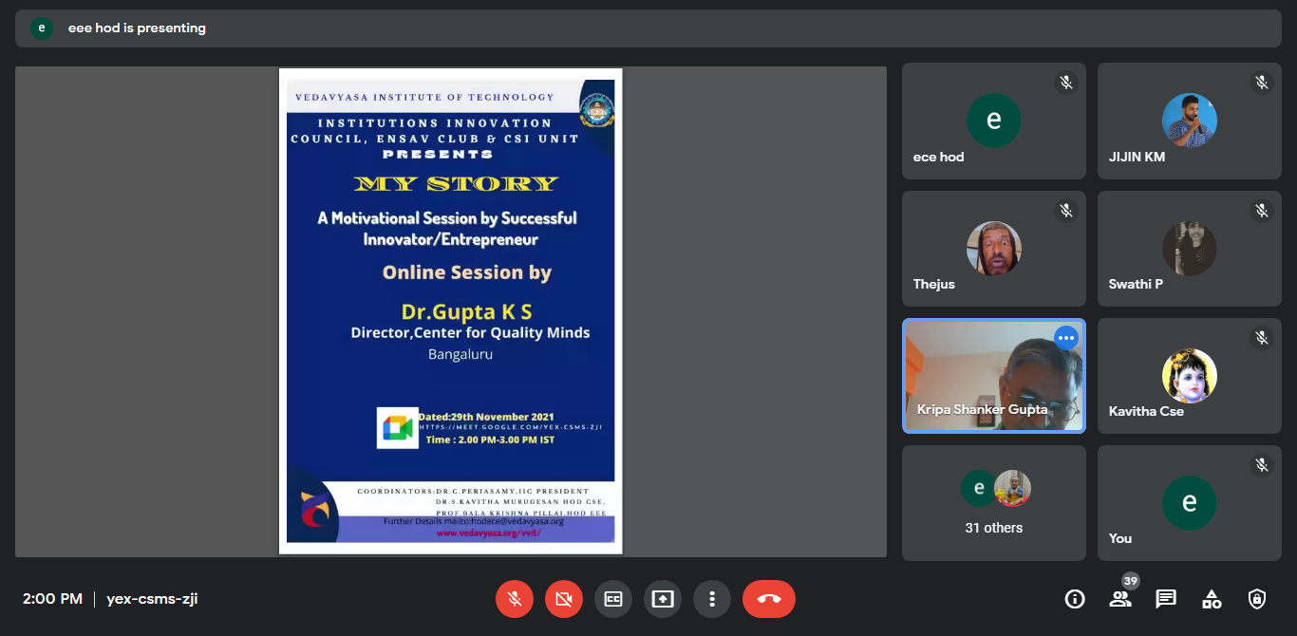
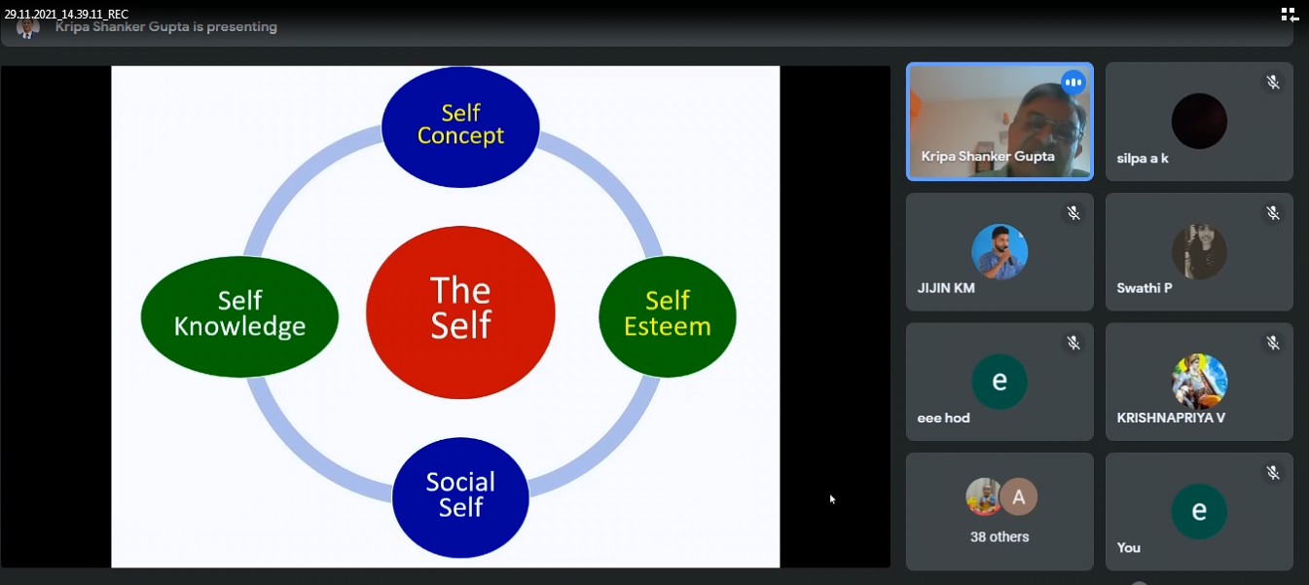
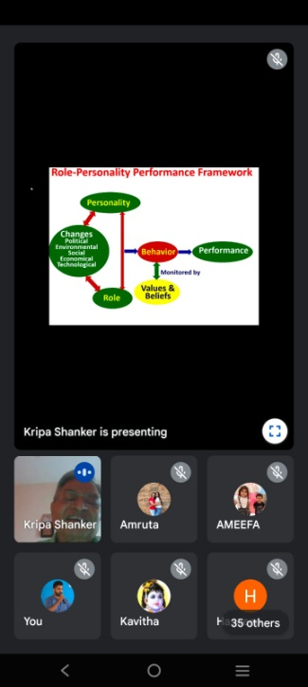
The activity was conducted during this semester and has given added benefits to student and faculty participants.

Dr S. Sangheethaa
Principal
Date 29.11.21

