Vedavyasa Institute of Technology, Karadparamba
Institution’s Innovation council - Activity Report
Program: Entrepreneurship Development Programme | Title of activity:  “Orientation Session on National Innovation and Startup Policy (NISP)
Organizer:  Institution’s Innovation council - VVIT | Name of coordinators:  Dr. Kavitha Murugesan Vice Principal | Date: 11.08.2021
Summary of activity:
The National Innovation and Startup Policy 2019 for students and faculty of Higher Education Institutions (HEis) will enable the institutes to actively engage students, faculties and staff in innovation and entrepreneurship related activities. This framework will also facilitate Ministry of Human Resource Development in bringing uniformity across HEI’s in terms of Intellectual Property ownership management, technology licensing and institutional. The session discussed the following areas.
- Strategies and Governance
- Startups Enabling Institutional Infrastructure
- Nurturing Innovations and Startups
- Product Ownership Rights for Technologies Developed at Institute
- Organizational Capacity, Human Resources and Incentives
- Creating Innovation Pipeline and Pathways for Entrepreneurs at Institute Level
- Norms for Faculty Startups
- Pedagogy and Learning Interventions for Entrepreneurship Development
- Collaboration, Co-creation, Business Relationships and Knowledge Exchange
- Entrepreneurial Impact Assessment.

Benefit to faculty/students:
- Practical engineering skills
- Knowledge acquisition
- Familiarity with real-world
- Decision Making skills as a leader
No of participants: 47 ( 29 Students and 18 Faculty)
Assessment/remarks of participants:

The webinar session is very nice and informative session. Some participants give appreciation as excellent.
Name, designation of external resource person:

Dr. Periasamy.C
President II Council, VVIT

The above mentioned activity was scheduled in accordance with the requirement of APJ Abdul Kalam Technological University to provide opportunity to earn activity points. The activity was informative with rate of good success

Signature of Coordinator

Documents accompanying:
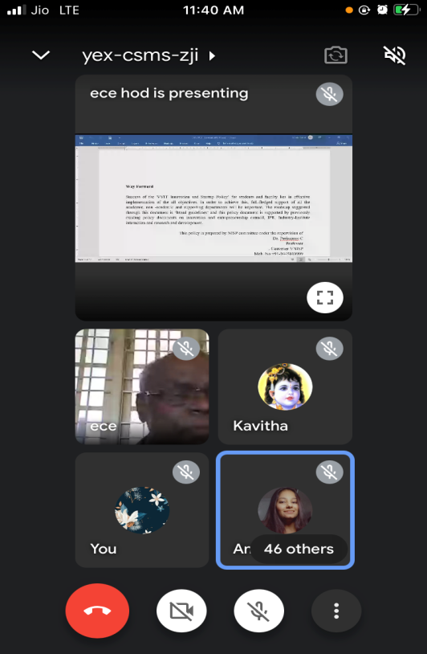
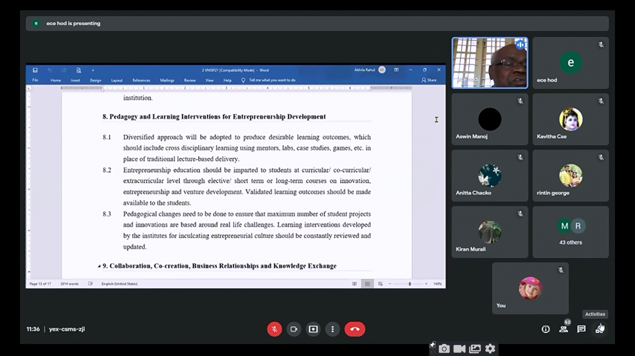
The activity was conducted during this semester and has given added benefits to student and faculty participants.

Dr S. Sangheethaa
Principal
Date 11.08.21

