Institution’s Innovation council
Activity Report
IIC 4 Sem 1- Q2- MIC Driven Activity
Program:  MIC Driven Activity - E-Symposium | Title of activity:  E-Symposium on Building Innovation Ecosystem in Educational Institutions- Day 1 (11th Jan 2022)
Organizer:  The Institution’s Innovation Council (IIC) | Name of coordinators:  Dr. C. Periasamy, President, IIC | Date: 11/01/2022  Time : 10.30 AM – 4.30 PM  Venue: MOE - Online
Name, designation of resource person:
- Shri Sridhar Vembu, Founder ZOHO Corporation
- Shri. Gautam Kumar, Founder, FarEye Pvt. Ltd
Summary of activity:
This event started with Inaugural Session followed by Keynote Address- II: Invited Key Note Address by Shri. Gautam Kumar, Founder, FarEye Pvt. Ltd, Panel Discussion I: Innovation, Human Values, & Sustainability, Keynote Address-I: Invited Key Note Address by Shri Sridhar Vembu, Founder ZOHO Corporation and the session continues to 12th January 2022.

Benefit
This Program is benefited for the faculty, students and alumni of the institution.

No of participants: 40 (25 Students, 10 Faculty and 5 Alumni)
Assessment/remarks of participants:
It was a good session. The session was interesting and informative It is really helpful and awesome that gives us Innovation, Human Values, & Sustainability.

Documents accompanying: Snapshots of the session
Inaugural Session: Azadi Ka Amrit Mahotsav: Innovation Week Celebration
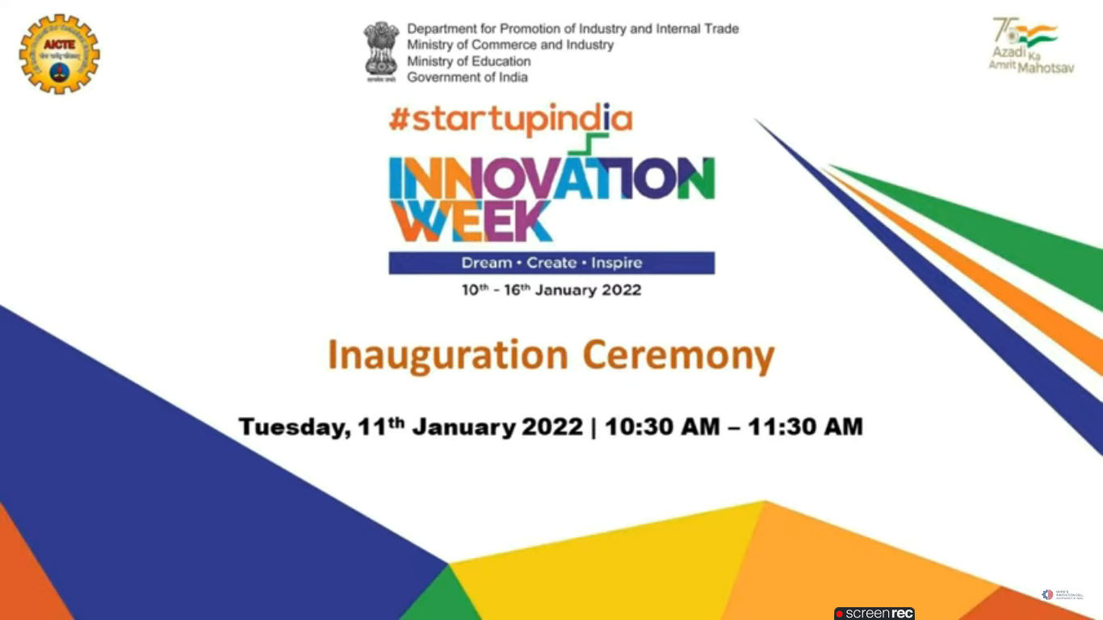

Keynote Address-I: Invited Key Note Address by Shri Sridhar Vembu, Founder ZOHO Corporation
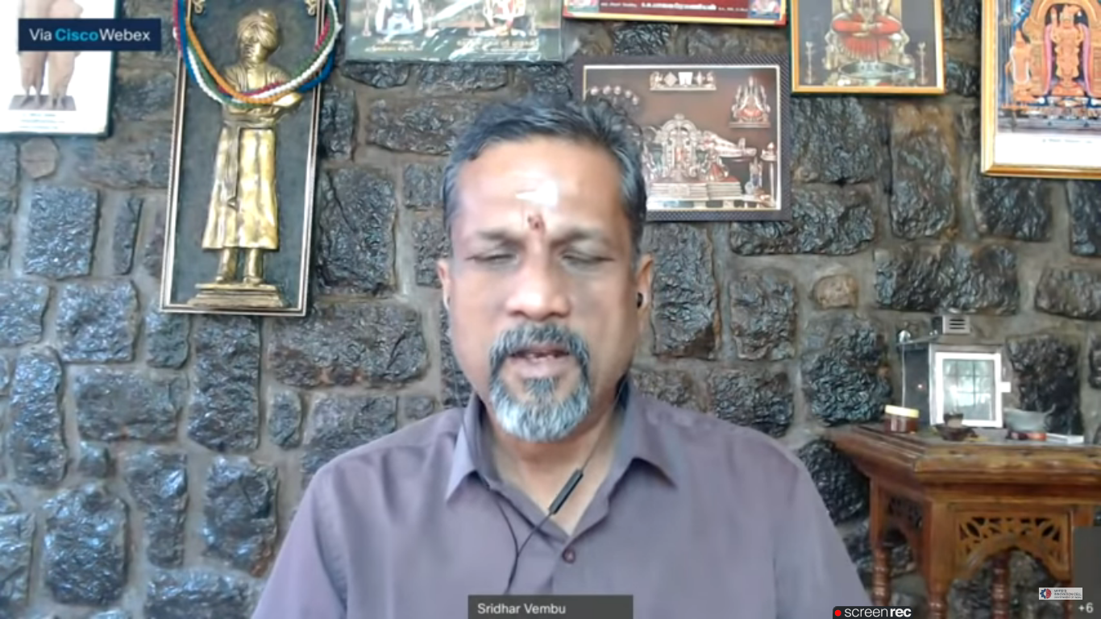

Panel Discussion I: Innovation, Human Values, & Sustainability
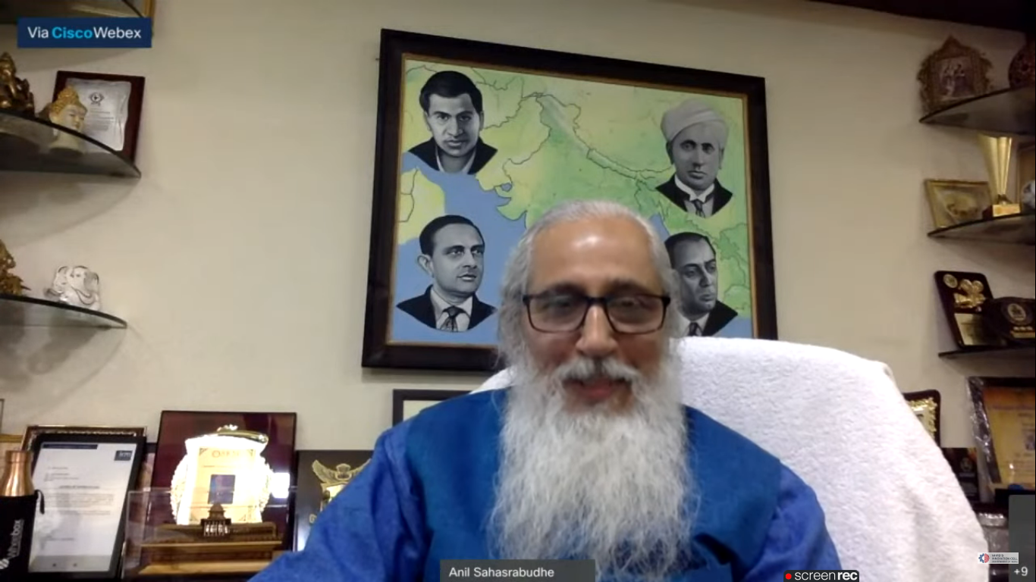

Keynote Address- II: Invited Key Note Address by Shri. Gautam Kumar, Founder, FarEye Pvt. Ltd
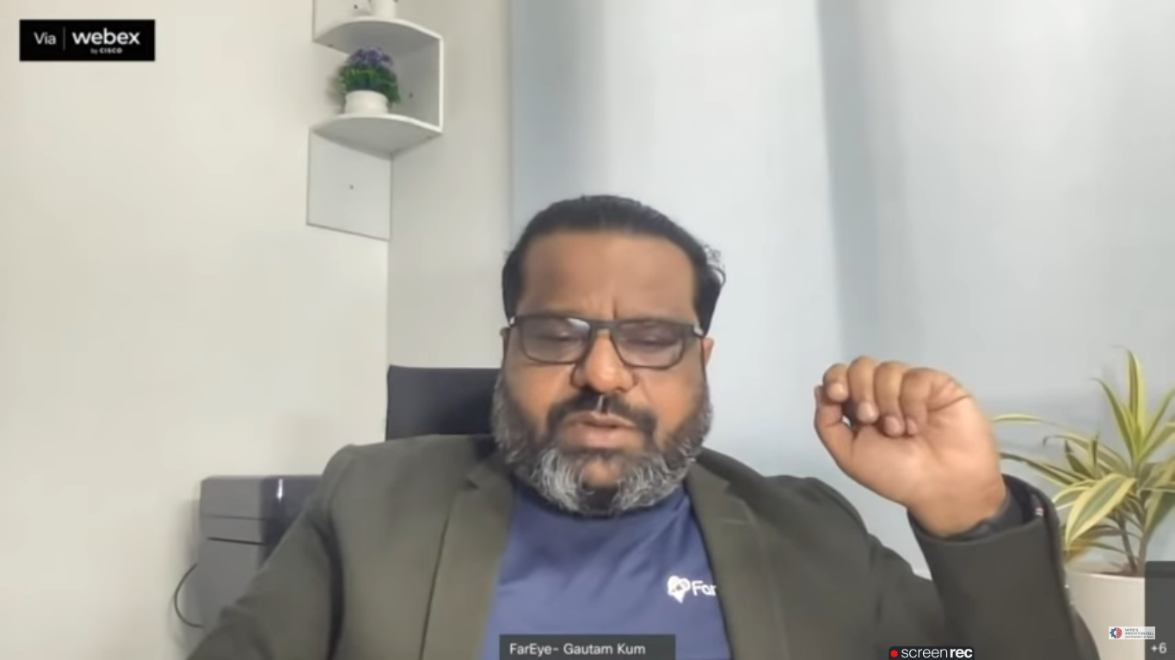

This activity was conducted by MOE and has given added benefits to student, alumni and faculty participants.
Dr S. Sangheethaa
Principal
Date 11.01.2022

