Institution’s Innovation council
Activity Report
IIC 4 Sem 1- Q2- Calendar Activity
Program:  IIC Calendar activity | Title of activity:  Entrepreneurship Skill, Attitude and Behavior Development
Organizer:  The Institution’s Innovation Council (IIC) | Name of coordinators:  Dr. Kavitha Murugesan President CSI unit | Date: 18/01/22  Time : 11.00 – 01.00  Venue: VVIT
Name, designation of resource person:
Ms. BABITHA
Assistant Professor – S& H Department – VVIT.
Summary of activity:
This session started with the welcome address by Ms. Haseena AP EEE and followed with the felicitations from Dr. Kavitha Murugesan. The speaker covered the following points. Passion. Bravery, flexibility, strong work ethic, integrity., The presentation was supported by feedback and discussions. The vote of thanks was delivered by Mr Rahul IR.
Benefit to faculty/students:
- Knowledge acquisition
- Decision Making skills as a leader

No of participants: 32 (22Students and 10Faculty)
Assessment/remarks of participants:
The session was interesting and informative It is really helpful and awesome that gives us an idea how to identify. Entrepreneurship Skill, Attitude and Behavior Development

Documents accompanying: Snapshots of the session, poster
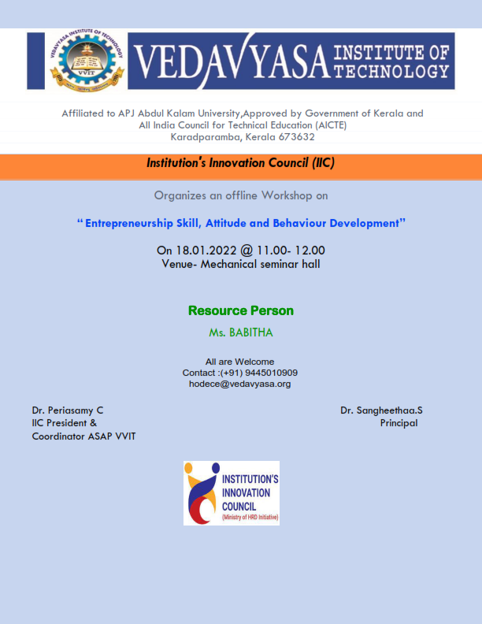
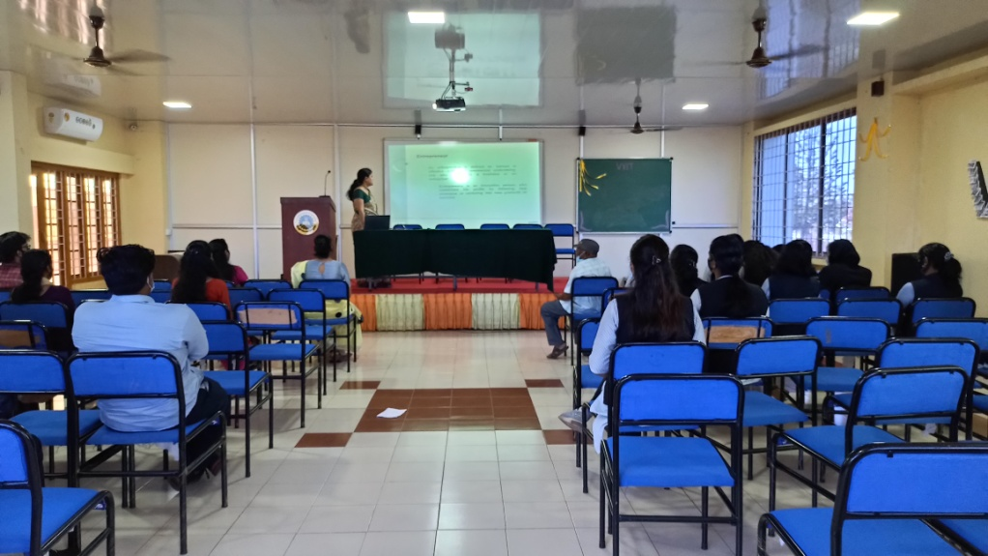
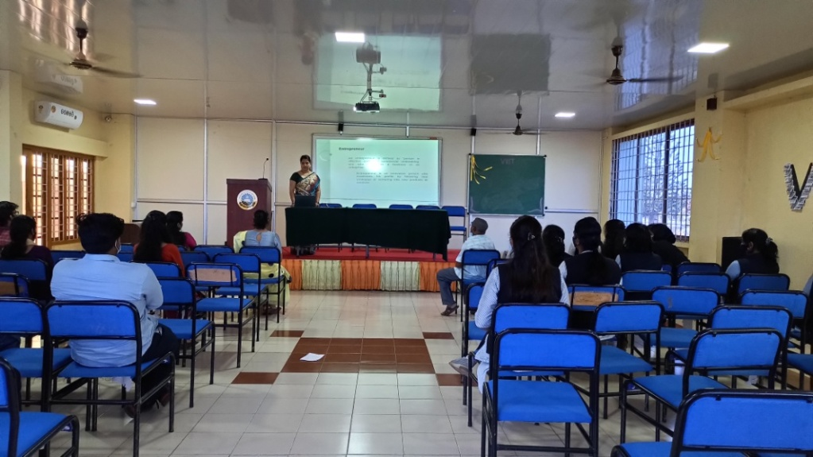
The activity was conducted during this semester and has given added benefits to student and faculty participants.
Dr S. Sangheethaa
Principal
Date 18.01.22

