Institution’s Innovation council
Activity Report
Self Driven Activity for IIC Academic Year 2021-22
IIC 4 Sem 2- Q3
Program:  Meeting | Title of activity:  “Progress review meeting for the Mentor-Mentee scheme”
Organizer:  MoE's Innovation Cell | Name of coordinators:  Selvarani  Innovation Officer  Ministry of Education's Innovation Cell, AICTE | Date: 22/04/2022  Time : 03.00 pm  Venue: Online
Name, designation of resource person:
Mr. Dipan Sahu,
Assistant Director,
MoE’s Innovation Cell.
Summary of activity:
This session discusses the following points
- Activities conducted by mentor institutions and participation from mentee institutions
- Performance of mentor and mentee institutions
- Regular Update of activities in the IIC Portal by Mentor and Mentee institutions
- Reports to be submitted by Mentors
- Region wise active/Inactive Mentors
- Interaction with participants
Resource person suggested that all Mentor Mentees Institutions shall actively participate in activities.
VVIT reports the all the activities are progressing as per MOEs Innovation Council
Benefit to faculty/students
Mentoring is "journeying with". The mentor participates in the formation of the personality of the mentored, giving meaning and a clear purpose to life. The mentor, of necessity, will listen to and understand, and guide her ward along the vicissitudes of student life which at times may be stormy and turbulent

No of participants: 60 faculy and experts
Dr Periasamy C IIC PRESIDENT, VVIT
Assessment/remarks of participants:
The mentor works towards helping the mentored achieve her goal of a valued university degree and a maturity that will help her experience a sense of accomplishment at having successfully completed a university education with the skills required to make her employable and successful in whatever sphere of life she may choose to explore.

Documents accompanying: Snapshots of the session, poster
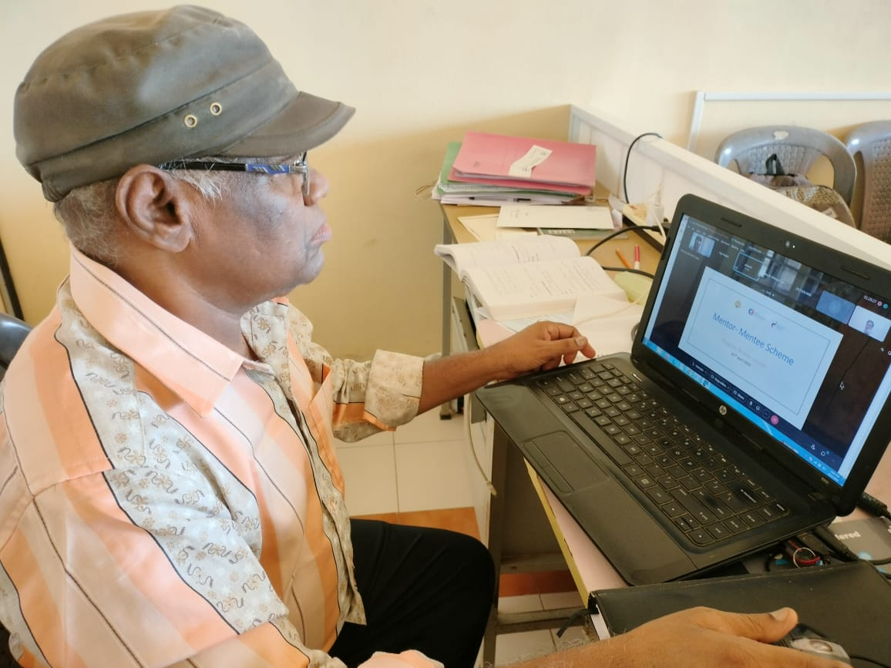
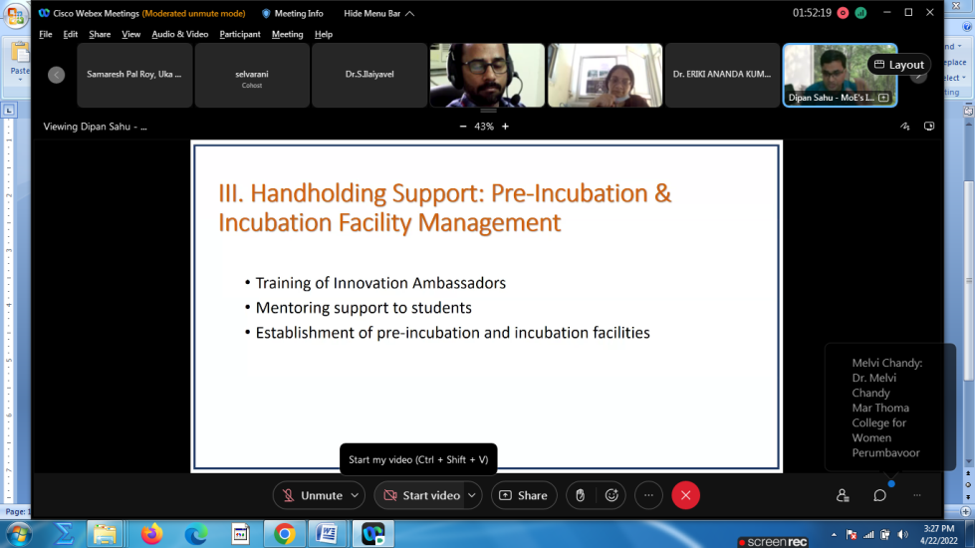
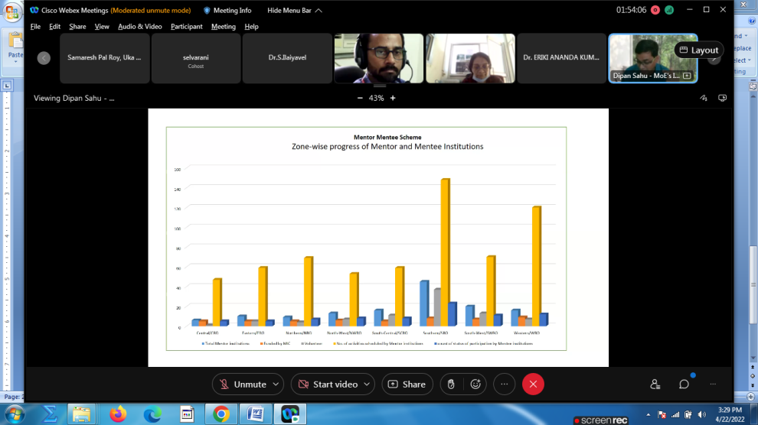
The activity was conducted during this semester and has given added benefits to student and faculty participants.

Dr S. Sangheethaa
Principal
Date 23.04.22

