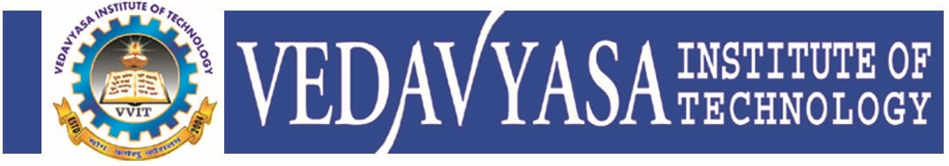
Institution’s Innovation council
Activity Report
IIC4- Q1-Calender Activity
Program:  Field Visit | Title of activity:  Exposure and field visit for problem identification
Organizer:  The Institution’s Innovation Council (IIC) in Association with ICI Calicut | Name of coordinators:  Ms Divya KK HOD CE  Mr Sreejith AP CE | Date: 25/11/2021 & 26/11/2021
Summary of activity:
This Activity starts on 25th November with site visit to a RCC residential project at Kottakal and a steel structure (Triangle convention centre) at athavanad both of d&E architects were done. The plan and the details of both the structures were explained by the principal consultant of the firm. On 26th November a plant visit to Rocks Ready mix pvt ltd was carried out. The concrete tests were conducted in laboratory. The complete process of ready mix concrete production and transportation was shown and explained. The quary and crusher of the same plant was also visited. The process for the same was explained. The Activity ends with feedback and question answers session.
Benefit to faculty/students:
- Practical engineering skills
- Knowledge acquisition
- Familiarity with real-world
- Decision Making skills as a leader

No of participants: 59 ( 51 Students and 8 Faculty)
Assessment/remarks of participants:

This Activity is interesting and informative. It is really helpful and awesome that gives an industrial exposure to students.

Name, designation of external resource person:

Mr Abdul Latheef, Architect d&E architects, Malppuram

The above mentioned activity was scheduled in accordance with the requirement of APJ Abdul Kalam Technological University to provide opportunity to earn activity points. The activity was informative with rate of good success

Signature of Coordinator

Documents accompanying:
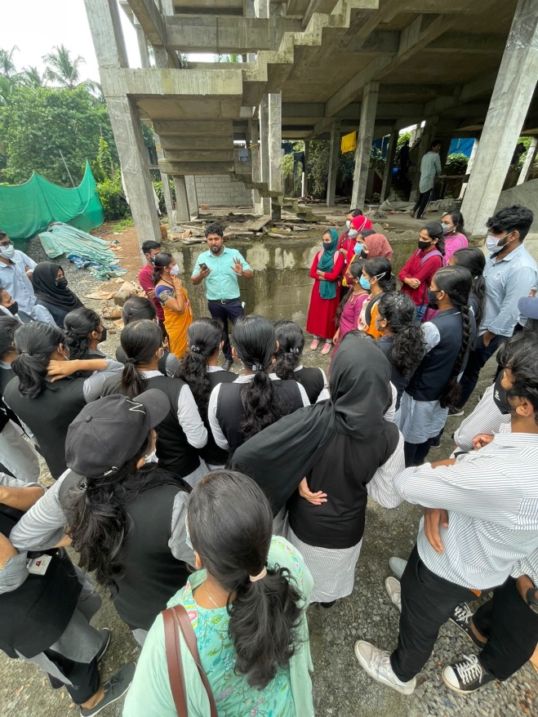
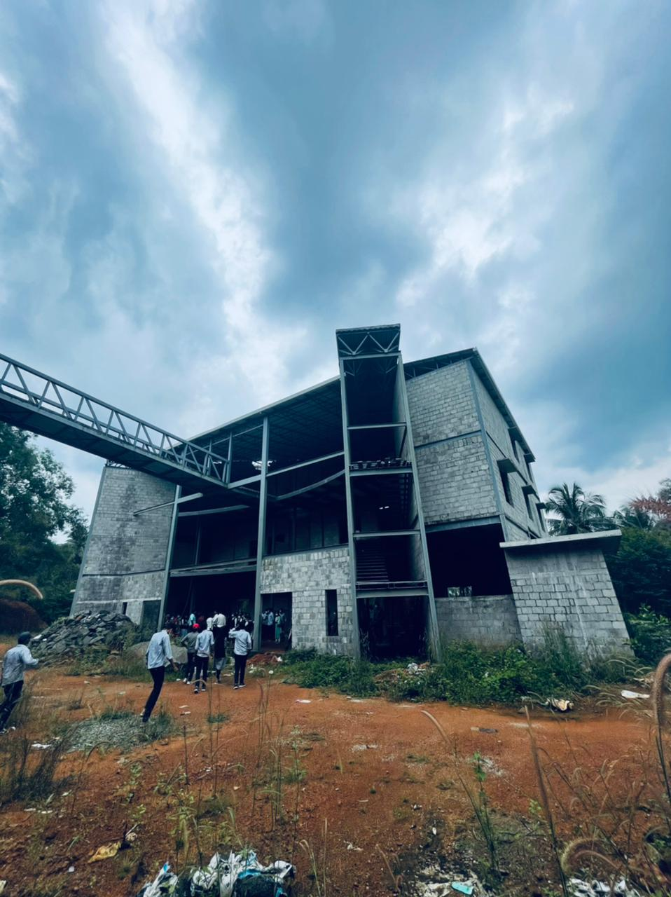
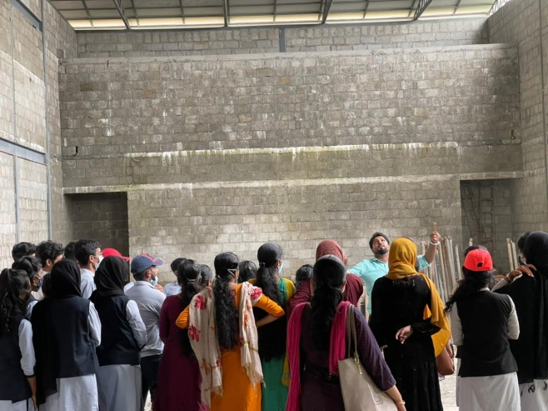
The activity was conducted during this semester and has given added benefits to student and faculty participants.

Dr S. Sangheethaa
Principal
Date 26.11.21

