Vedavyasa Institute of Technology, Karadparamba
Institution’s Innovation council - Activity Report
Program: Entrepreneurship Development Programme | Title of activity:  “Prototype Validation-Converting Prototype into Startup”
Organizer:  Institution’s Innovation council - VVIT | Name of coordinators:  Dr. Periasamy.C President II Council, VVIT  Dr. Kavitha Murugesan Vice Principal | Date: 06.07.2021
Summary of activity:
The session discussed the importance of planning. The basics of invention and innovation were discussed. Entrepreneurship is highly risky but also can be highly rewarding, as it serves to generate economic wealth, growth, and innovation. Indian scenario entrepreneurs were also presented in this session. It discussed the traditional business and startup business. The challenges and issues in startups were also discussed. The session ended with interested quiz program.
Benefit to faculty/students:
- Practical engineering skills
- Knowledge acquisition
- Familiarity with real-world
- Decision Making skills as a leader

No of participants: 60 ( 29 Students and 31 Faculty)
Assessment/remarks of participants:
The session provided informative and most helpful tips about startup to engineering teachers/faculty.
Name, designation of external resource person:
Er. RAMASAMY MURUGA MUDALIAR
Vice President QDT Technology Bangalore

The above mentioned activity was scheduled in accordance with the requirement of APJ Abdul Kalam Technological University to provide opportunity to earn activity points. The activity was informative with rate of good success

Signature of Coordinator

Documents accompanying:
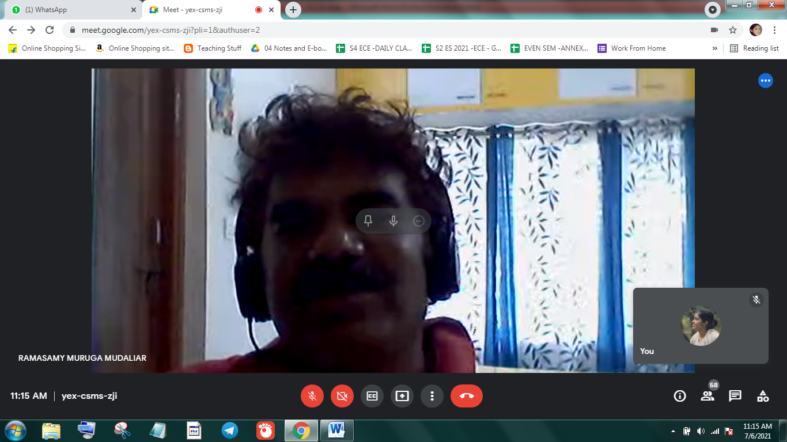
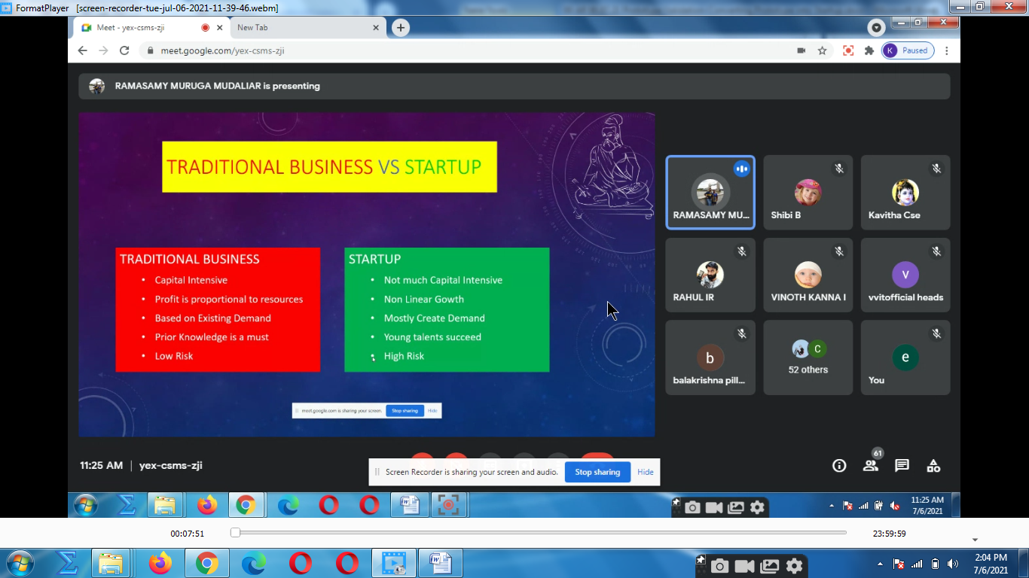
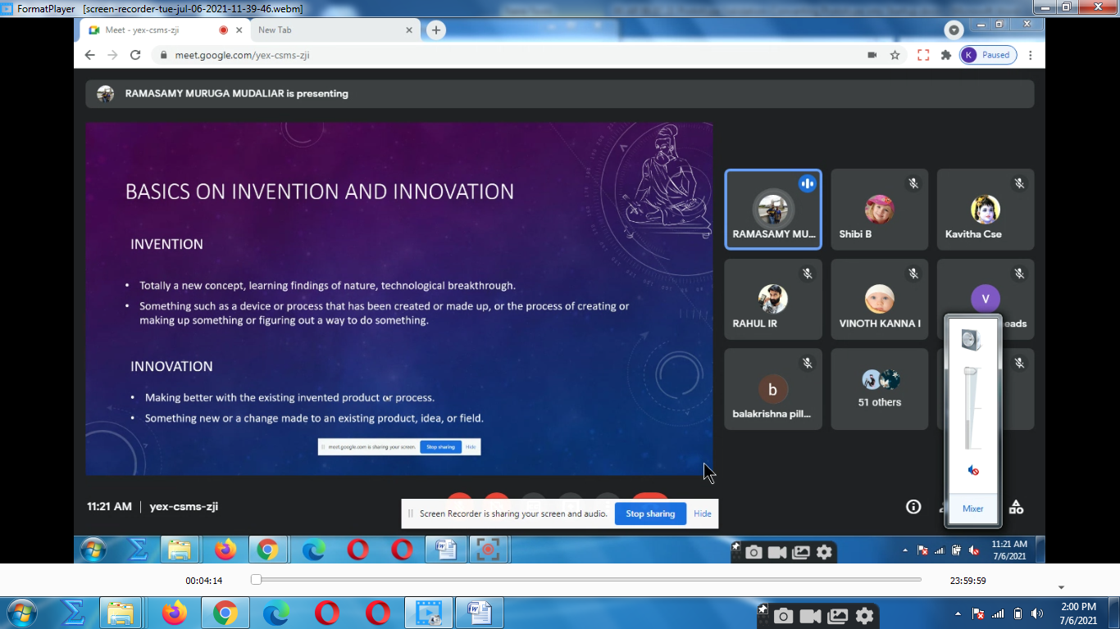
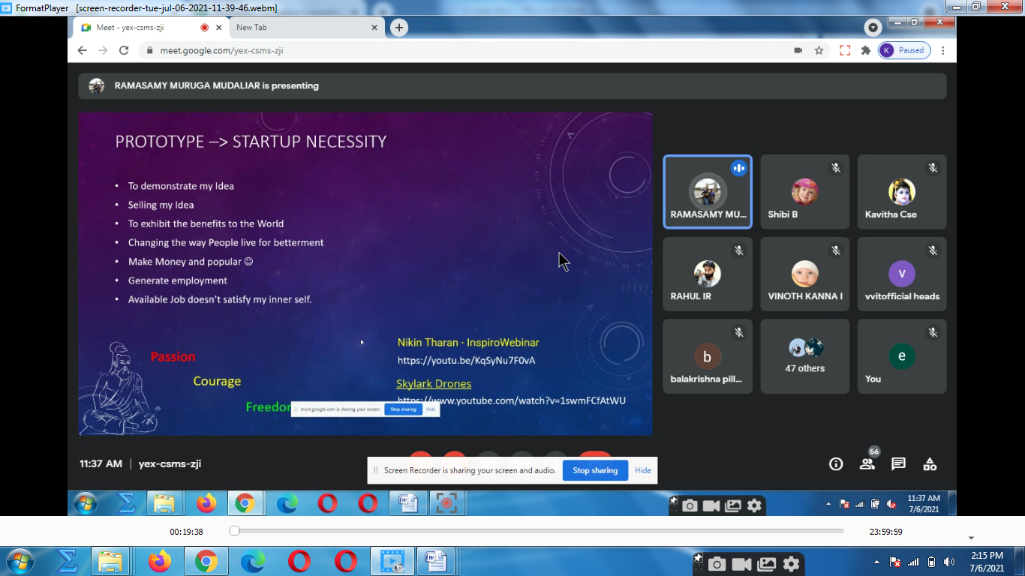
The activity was conducted during this semester and has given added benefits to student and faculty participants.

Dr S. Sangheethaa
Principal
Date 06.07.21

