Vedavyasa Institute of Technology, Karadparamba
Institution’s Innovation council - Activity Report
Program:  Webinar | Title of activity:  Session on MY STORY – A motivational Session by Successful Entrepreneur/ Start-up founder
Organizer:  The Institution’s Innovation Council (IIC) and CSI chapter of VVIT | Name of coordinators:  Dr. Kavitha Murugesan  Vice Principal  Dr. Periasamy.C  President II Council, VVIT | Date: 02.11.2021
Summary of activity:
Institution innovation council of VVIT organized a one-day webinar on November 02, 2021, titled ‘My Story- Motivational Session by Successful Entrepreneur/Startup Founder’ in association with CSI Chapter of VVIT. It was well-received by more than 52 participants of various colleges. Ms . Amruta started the session with a warm welcome to all the attendees, introduced the IIC- VVIT, and gave an overview of its’ function & activities. He then introduced the guest speaker. The session was delivered by guest speaker Mr. Raman Unni who is the CEO, ChargeMOD BPM Power P Ltd Kozhikode.He started the session by stating the company’s vision and some impressive, yet important facts about the journey & growth of the company so far. He gave an insight into some common beliefs that budding entrepreneurs have about initiating their projects and start-up ideas especially about beginning one. He also enlightened the audience about the opportunities and challenges that Covid-19 has created. He encouraged the audience to follow their dreams of building their own start-ups saying that one should not be afraid in taking the first step towards their goal. The session was quite interactive. The session ended with a Q&A , feedback session, giving the participants opportunity to clarify their doubts about entrepreneurship. The vote of thanks was delivered by student coordinator Mr. Dilshad.
Benefit to faculty/students:
- Practical engineering skills
- Knowledge acquisition
- Familiarity with real-world
- Decision Making skills as a leader

No of participants: 63 ( 52 Students and 11 Faculty)
Assessment/remarks of participants:

The webinar session is very nice and informative session. Some participants give appreciation as excellent.
Name, designation of external resource person:

Mr. Raman Unni
CEO, ChargeMOD
BPM Power P Ltd Kozhikode.

The above mentioned activity was scheduled in accordance with the requirement of APJ Abdul Kalam Technological University to provide opportunity to earn activity points. The activity was informative with rate of good success

Signature of Coordinator

Documents accompanying:
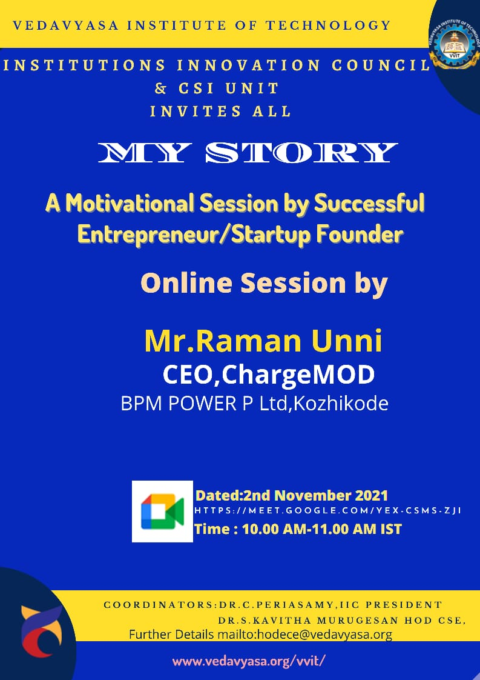
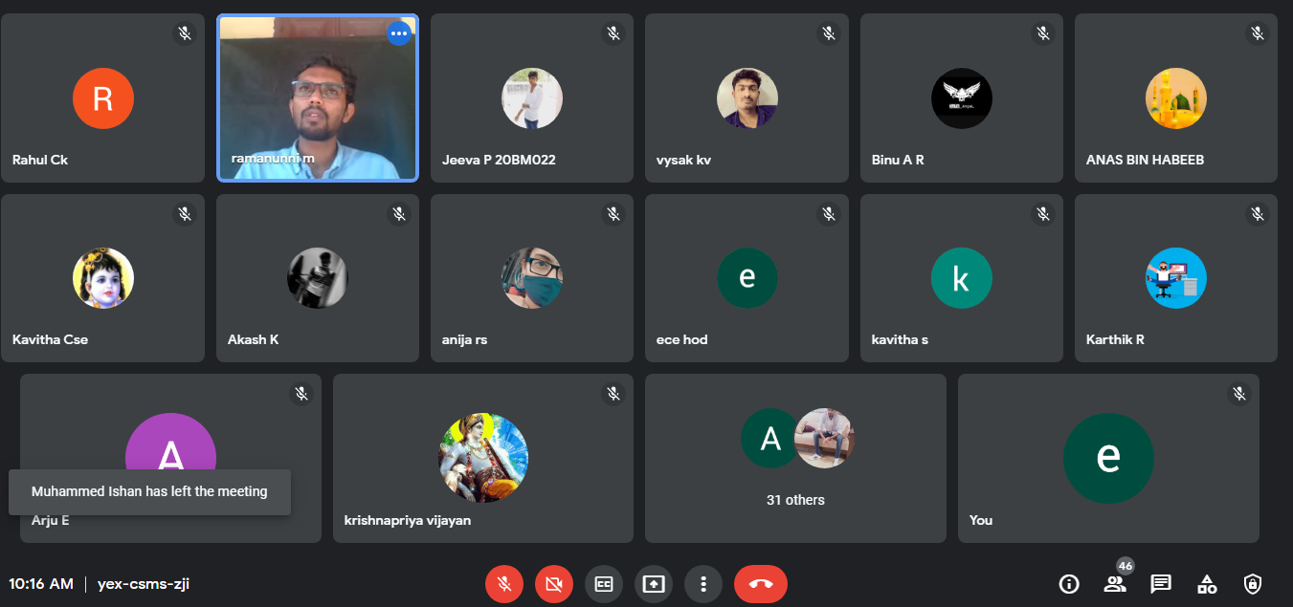
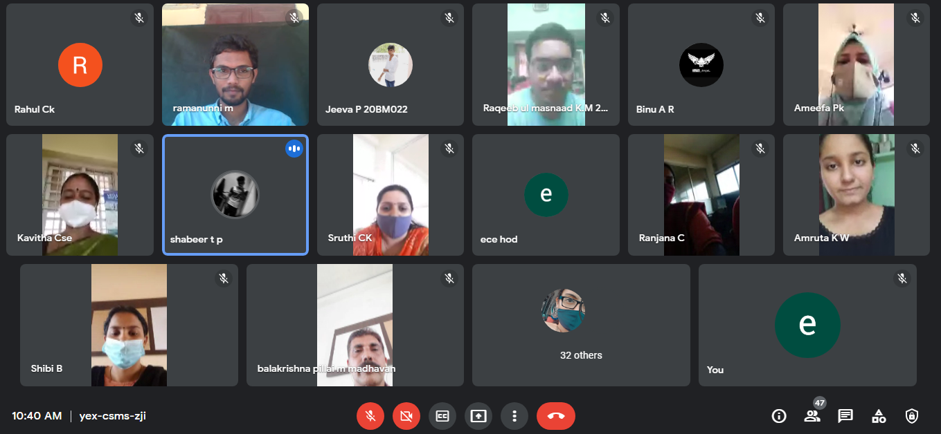
The activity was conducted during this semester and has given added benefits to student and faculty participants.

Dr S. Sangheethaa
Principal
Date 02.11..21

