Institution’s Innovation council
Activity Report
IIC4 Sem 1- Q2 Important Day Celebration Activity- Academic Year 2021-22

for IIC

Program:  National Energy Conservation Day(India)  Important Day Celebration Activity | Title of activity:  Awareness seminar about energy conservation and a rally on energy conservation
Organizer:  The Institution’s Innovation Council (IIC) in Association with EnSav club, EEE and ECE Departments. | Name of coordinators:  Mr.Jijin K M, AP, EEE Department | Date : 14/12/2021  Time : 11.00am – 16.00pm  Venue: ME Seminar hall and Vazhayoor Panjayath for Rally
Name, designation of resource persons:
- Prof. Balakrishna Pillai
- Mr.Rahul I R, AP, ECE Department
Summary of activity:
The seminar started with the welcome address by Jijin , AP , EEE Department and followed by felicitations by Dr. Periasamy C. The speaker presented the innovative ideas for achieving energy utilization and conservation of targets highlighting the various measures required for purpose. He focused on saving energy in houses,streets and industries. The session was ended by feedback and discussions.

The rally was inaugurated by Dr.Sangheethaa -Principal. Then the students were divided into five groups. Each group carried pluck cards highlighting the importance of energy conservation in and around vazhayoor panjayath. They distributed the bit notices to all the residences of the local villages. They emphasized the benefits of energy conservation in the premises of villagers. The villagers started realizing the energy saving, appreciated the initiatives taken by each groups of VVIT and expressed their heartfelt gratitude.

Benefit to faculty/students:
- Practical engineering skills
- Knowledge acquisition
- Familiarity with real-world
Decision Making skills as a leader

No of participants: 37 (32Students and 5 Faculty)
Assessment/remarks of participants:
The seminar was interesting, informative and interactive. The rally was really helpful to the villages, so that they were happy to save some money from their hard earnings.
Documents accompanying: Snapshots of the session, poster
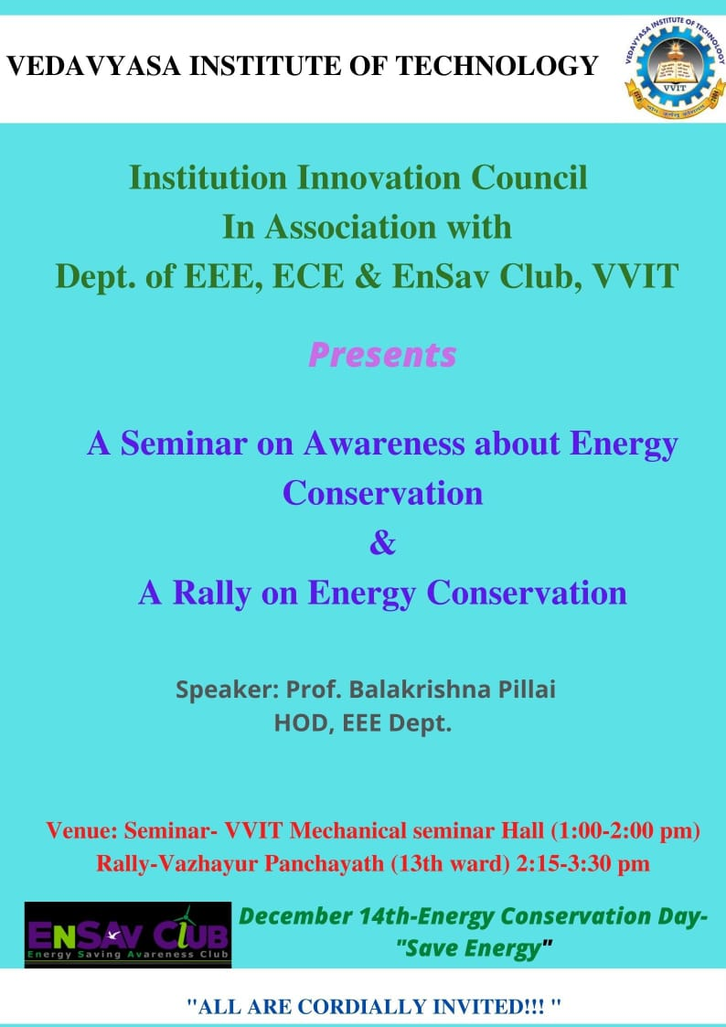
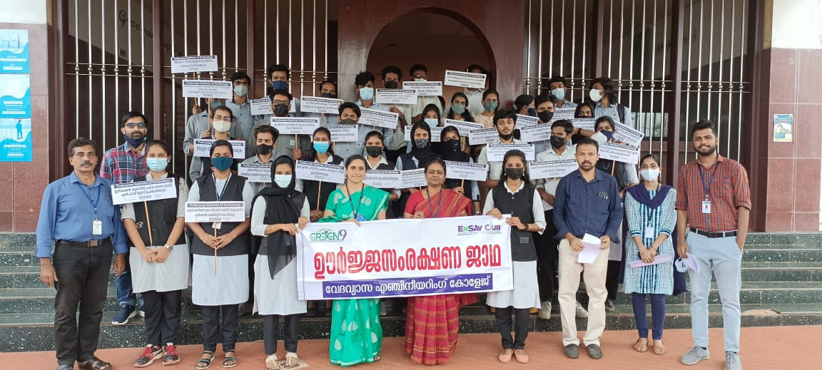
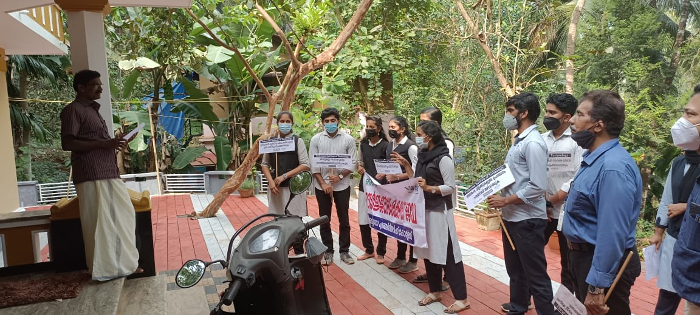
The activity was conducted during this semester and has given added benefits to student and faculty participants.
Dr S. Sangheethaa
Principal

