Vedavyasa Institute of Technology, Karadparamba
Institution’s Innovation council - Activity Report
Program: Entrepreneurship Development Programme | Title of activity:  “Orientation session for all students & faculties of Institute by Innovation  Ambassador”
Organizer:  Institution’s Innovation council - VVIT | Name of coordinator:  Dr Kavitha Murugesan HOD CSE | Date: 02.07.2021
Summary of activity:
An entrepreneur is an individual who creates a new business, and is enjoying most of the rewards. The process of setting up a business is known as entrepreneurship. An entrepreneur creates a firm to realize their idea, known as entrepreneurship, which aggregates capital and labor in order to produce goods or services for profit. Entrepreneurship is highly risky but also can be highly rewarding, as it serves to generate economic wealth, growth, and innovation. Indian scenario entrepreneurs were also presented in this session. The benefits include flexibility , Autonomy, constant growth and Greater self-confidence. The challenges may be in the forms of Cash Flow Management, Time Management, Hiring of Employees, Choosing The Product and Delegation of Tasks
Benefit to faculty/students:
- Practical engineering skills
- Knowledge acquisition
- Familiarity with real-world
- Decision Making skills as a leader

No of participants: 58 ( 20 Students and 38 Faculty)
Assessment/remarks of participants:
The session provided informative and most helpful tips about Entrepreneurship to engineering teachers/faculty.
Name, designation of external resource person:
Dr. Periasamy.C
President II Council, VVIT

The above mentioned activity was scheduled in accordance with the requirement of APJ Abdul Kalam Technological University to provide opportunity to earn activity points. The activity was informative with rate of good success

Signature of Coordinator

Documents accompanying:
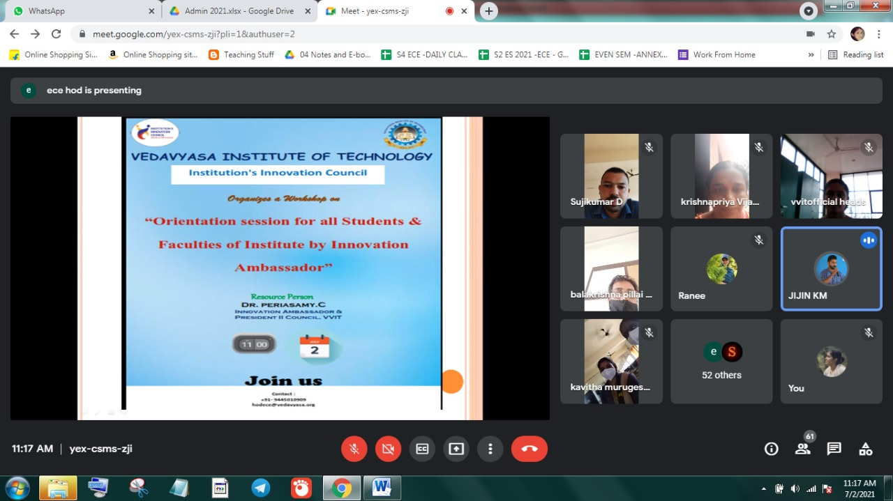
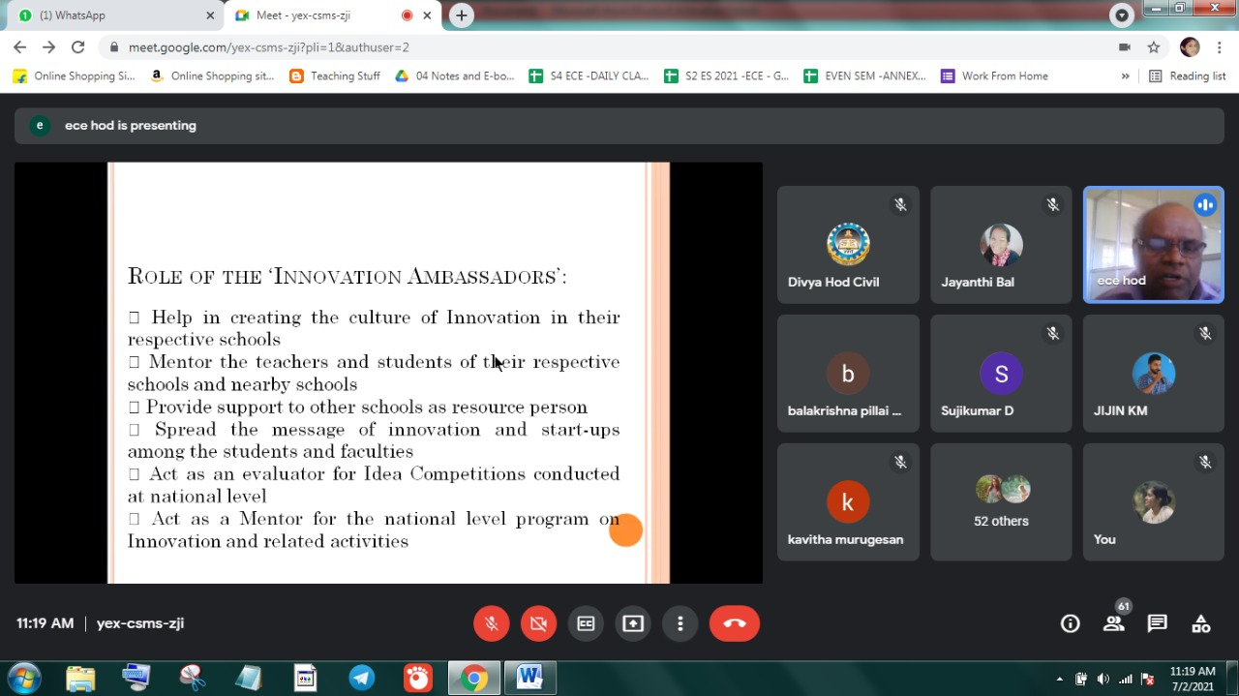
The activity was conducted during this semester and has given added benefits to student and faculty participants.

Dr S. Sangheethaa
Principal
Date 02.07.21

