Institution’s Innovation council
Activity Report
IIC 4 Sem 1- Q2- MIC Driven Activity
Program:  MIC Driven Activity - E-Symposium | Title of activity:  E-Symposium on Building Innovation Ecosystem in Educational Institutions- Day 2 (12th Jan 2022)
Organizer:  The Institution’s Innovation Council (IIC) | Name of coordinators:  Dr. C. Periasamy, President, IIC | Date: 12/01/2022  Time : 10.30 AM – 4.30 PM  Venue: MOE - Online
Name, designation of resource person:
- Prof. K VijayRaghavan, PSA, Govt. of India
- Shri Ankit Agarwal, Founder & CEO, Phool
Summary of activity:
This event started with Keynote Address-III: Address by Prof. K VijayRaghavan, PSA, Govt. of India, Panel Discussion III: Grey Hairs not mandatory to build great enterprises, Keynote Address-IV: Invited Key Note Address by Shri Ankit Agarwal, Founder & CEO, Phool, Panel Discussion- IV: Attracting Big Investment for Innovative ideas from Educational Institution, Panel Discussion-V: Schools, Innovation, Game and Curriculum and the session ended with Closing Ceremony of e-Symposium on Building Innovation & Entrepreneurial Ecosystem.

Benefit
This Program is benefited for the faculty, students and alumni of the institution.

No of participants: 40 (25 Students, 10 Faculty and 5 Alumni)
Assessment/remarks of participants:
It was a good session. The session was interesting and informative It is really helpful and awesome that gives us Big Investment for Innovative ideas from Educational Institution, Schools, Innovation, Game and Curriculum.
Documents accompanying: Snapshots of the session
Keynote Address-III: Address by Prof. K VijayRaghavan, PSA, Govt. of India
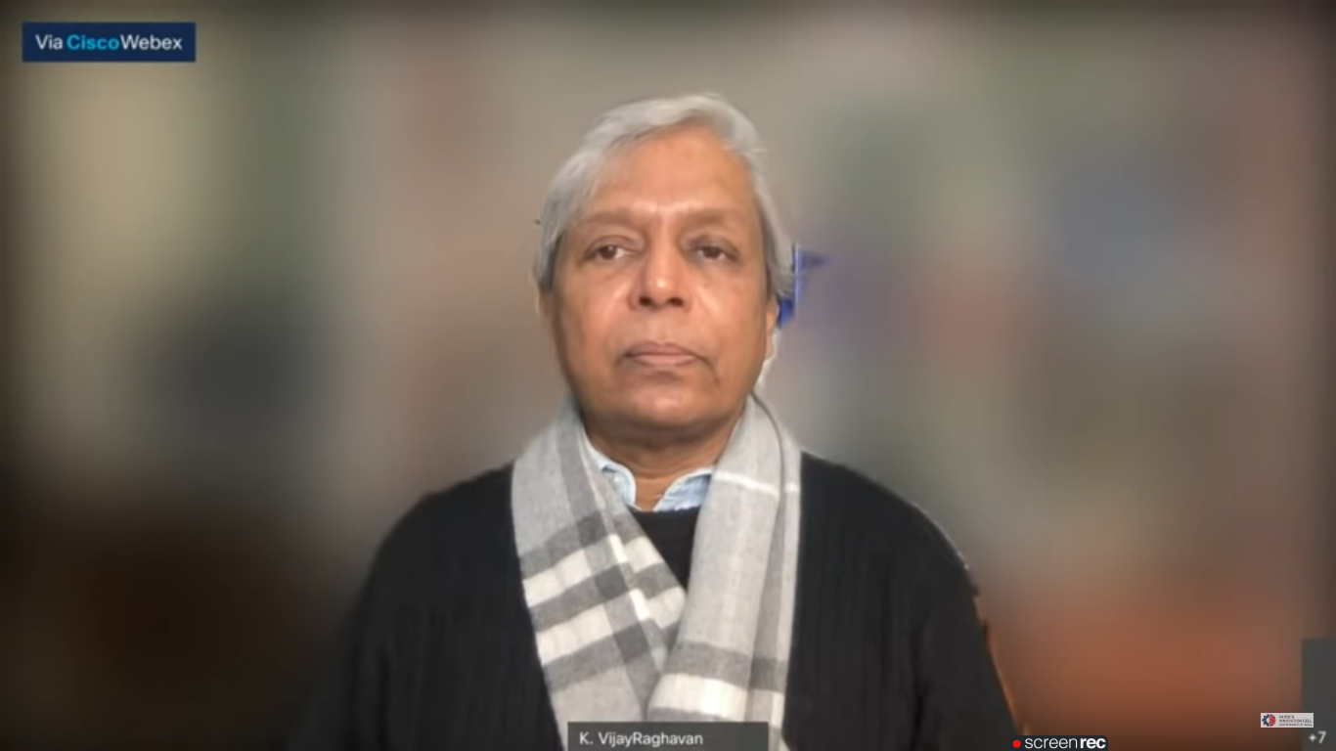

Panel Discussion III: Grey Hairs not mandatory to build great enterprises
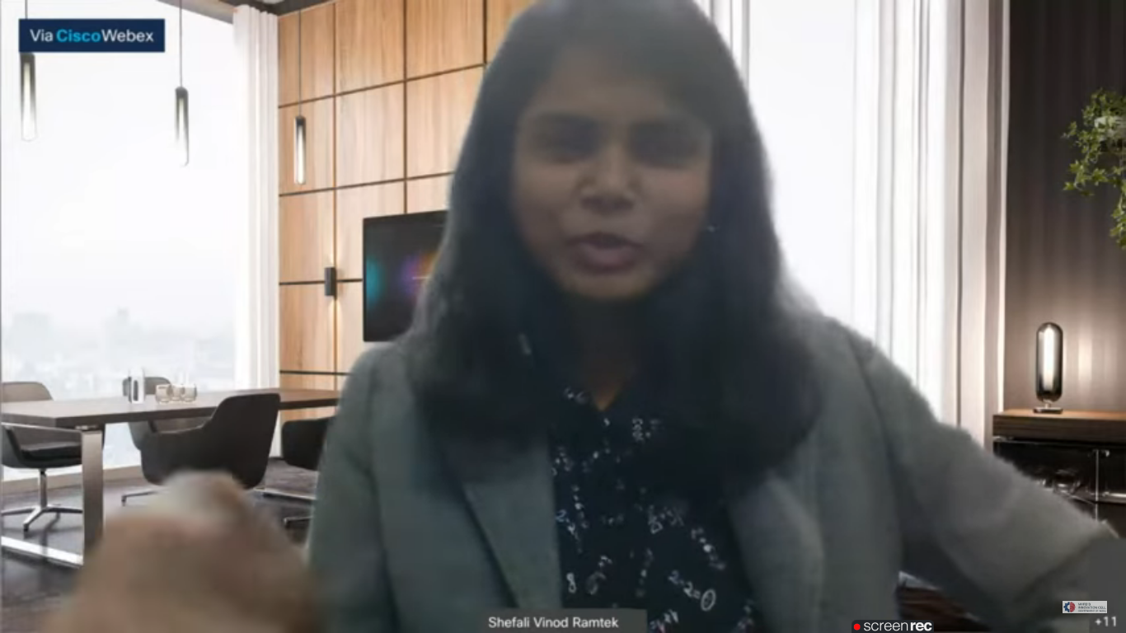

Keynote Address-IV: Invited Key Note Address by Shri Ankit Agarwal, Founder & CEO, Phool
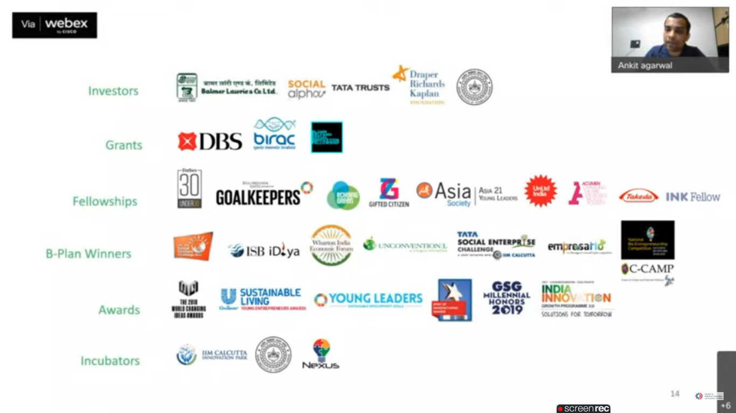

Panel Discussion- IV: Attracting Big Investment for Innovative ideas from Educational Institution
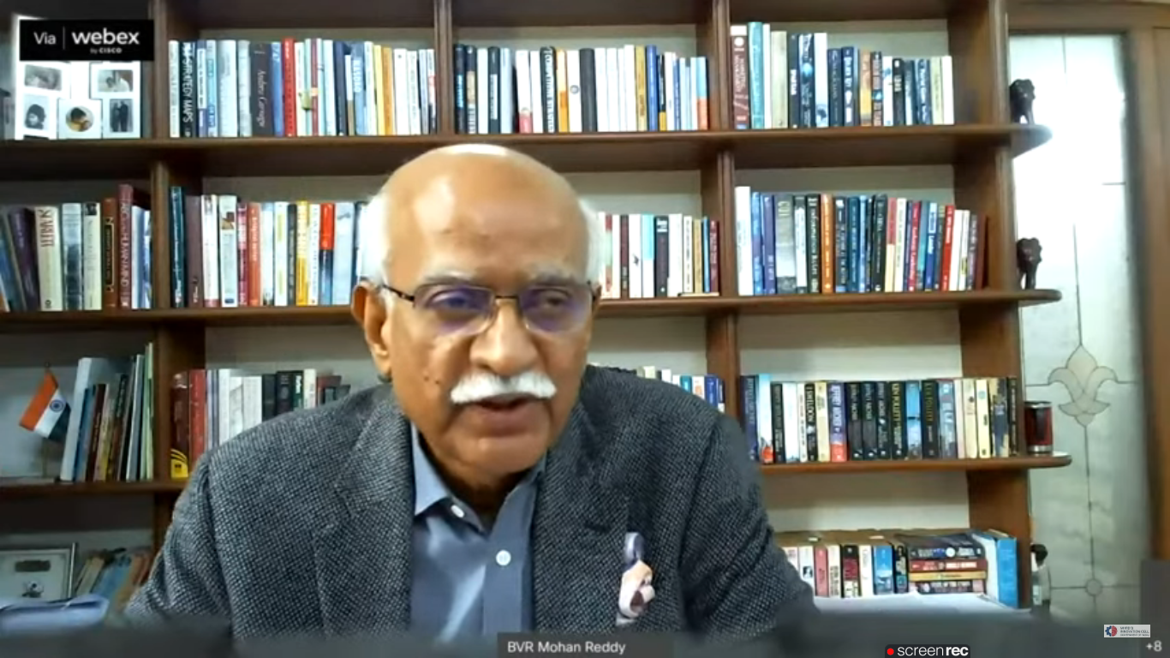

Panel Discussion-V: Schools, Innovation, Game and Curriculum
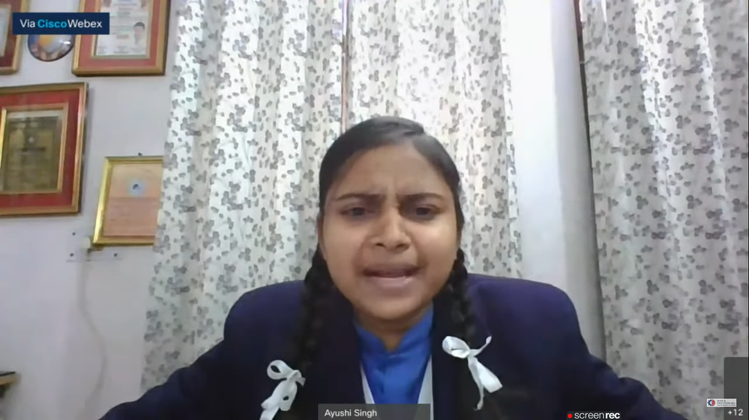

Closing Ceremony of e-Symposium on Building Innovation & Entrepreneurial Ecosystem
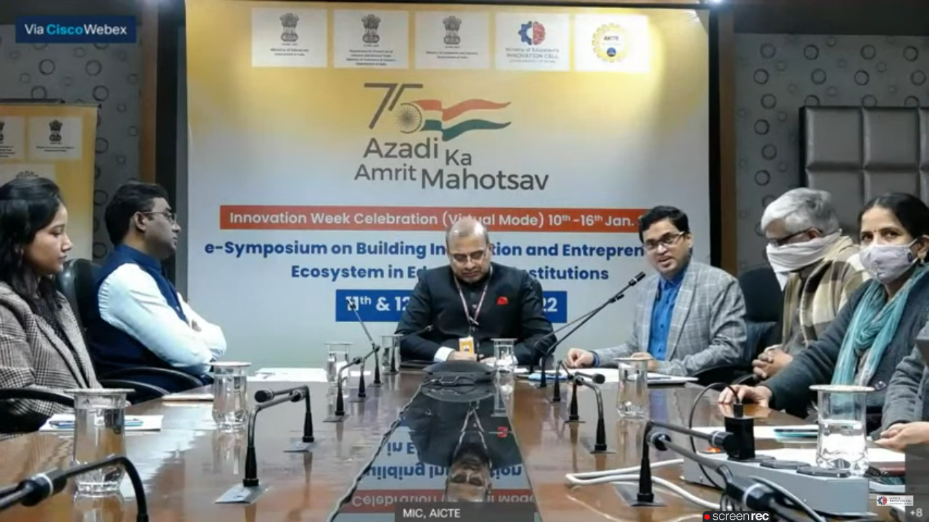

This activity was conducted by MOE and has given added benefits to student, alumni and faculty participants.
Dr S. Sangheethaa
Principal
Date 12.01.2022

