Vedavyasa Institute of Technology, Karadparamba
Industrial Institute Interaction Cell - Activity Report
Program: Entrepreneurship Development Programme | Title of activity:  A Session on “How to plan for Start-up and Legal & Ethical Steps”
Organizer:  III Cell- VVIT | Name of coordinator:  Dr.C.Periasamy III Cell president | Date: 03.06.2021
Summary of activity:
This presentation explains in a nutshell for budding entrepreneur to know about how to start a company. This explains about personality development and technical Capability for an entrepreneur. The topic covers Legal, Ethical Steps, Commercial Aspects, Compliance and Government Regulations to be considered for a company. Supporting resources and further readouts also suggested. The presentation ends with a simple quiz for the audience to get knowledge taken away.
Benefit to faculty/students:
- Practical engineering skills
- Knowledge acquisition
- Familiarity with real-world
- Decision Making skills as a leader

No of participants: 83 (Students and Faculty)
Assessment/remarks of participants:
The session was interesting and informative with enchanting words of the resource person
It is really helpful and awesome that gives us an idea how to start our own startups
It is useful to enhance the knowledge of each student
Name, designation of external resource person:
Er. Ramasamy Muruga Mudaliar - Vice President, QDT Technology Bangalore
The abovementioned activity was scheduled in accordance with the requirement of APJ Abdul Kalam Technological University to provide opportunity to earn activity points. The activity was informative with rate of good success

Signature of Coordinator
Documents accompanying:
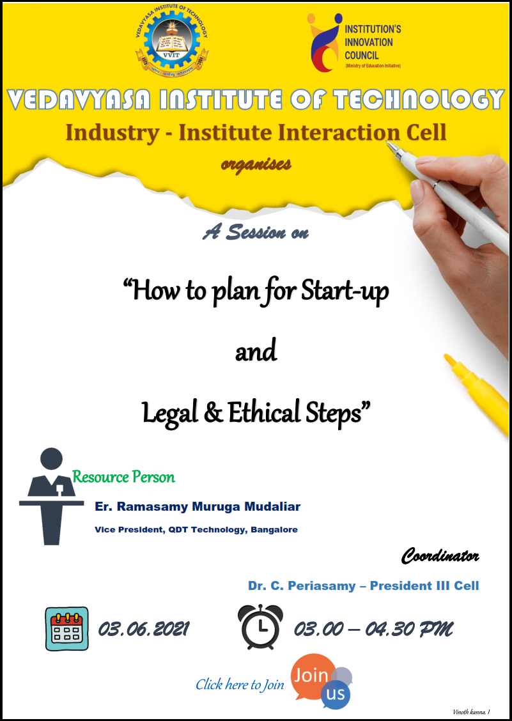
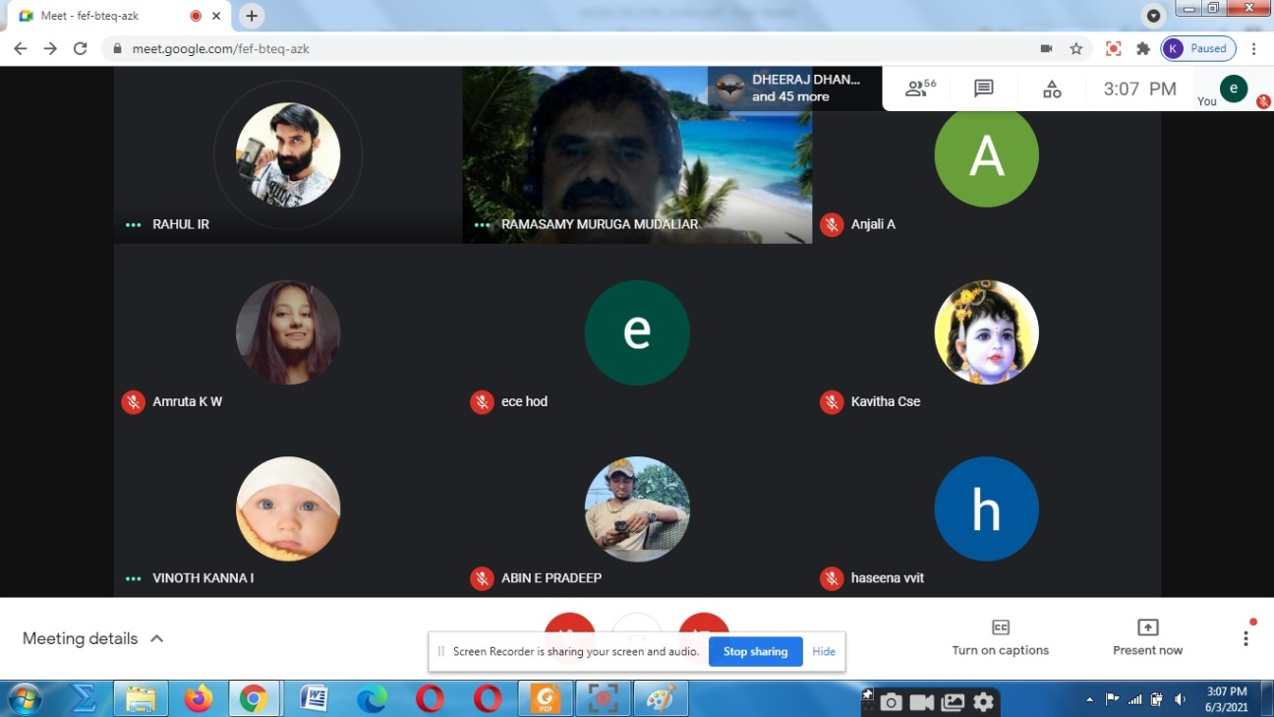
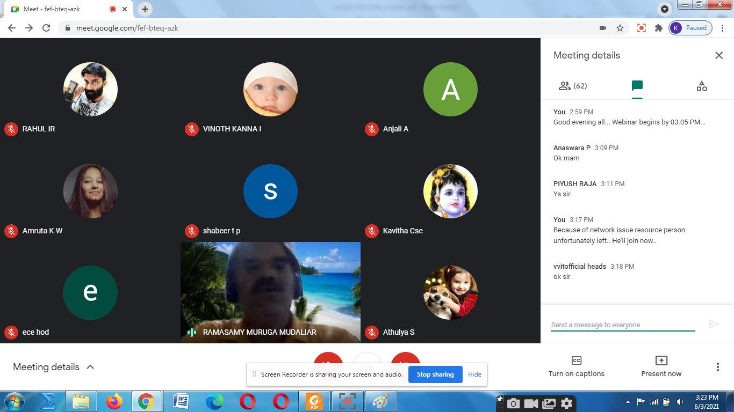
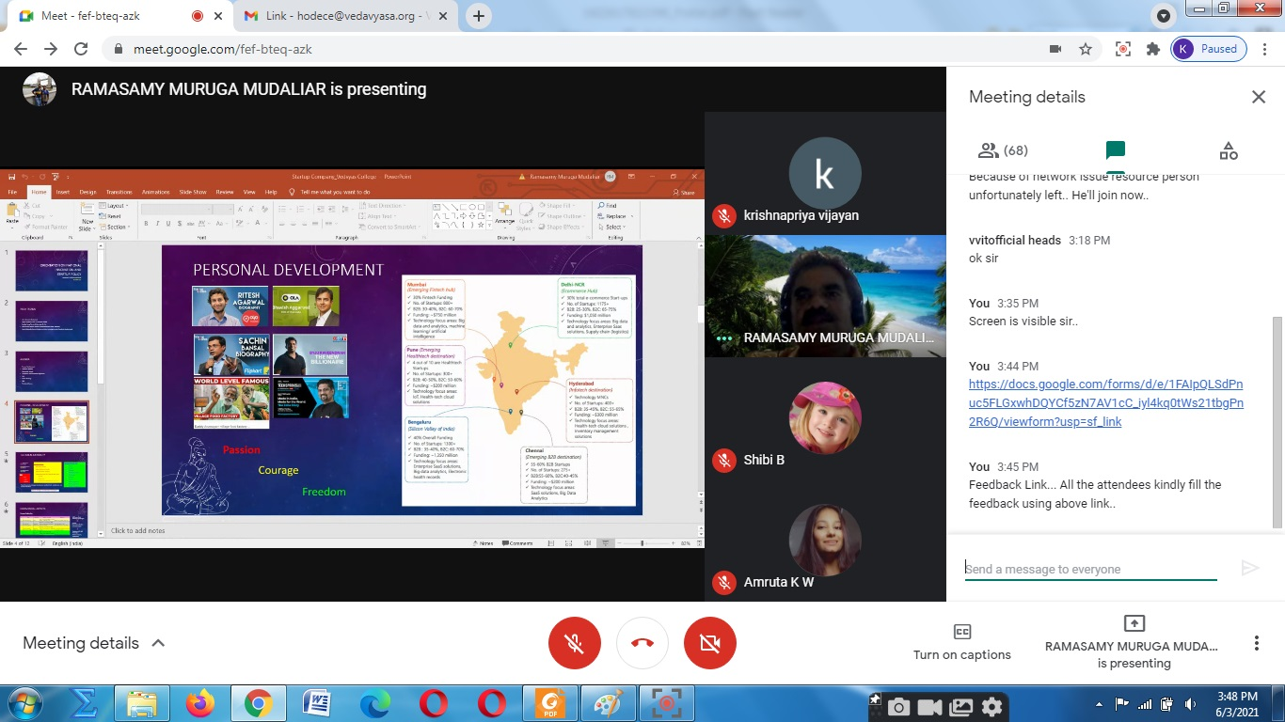
The activity was conducted during this semester and has given added benefits to student and faculty participants.

Dr S. Sangheethaa
Principal
Date

