Vedavyasa Institute of Technology, Karadparamba
Institution’s Innovation council - Activity Report
Program: Entrepreneurship Development Programme | Title of activity:  Session on Identifying Intellectual Property component at the early stage of innovation”
Organizer:  Institution’s Innovation council - VVIT | Name of coordinators:  Dr. Periasamy.C  President II Council, VVIT  Dr. Kavitha Murugesan  Vice Principal | Date: 16.08.2021
Summary of activity:
Intellectual property (IP) is a category of property that includes intangible creations of the human intellect. The most well-known types are copyrights, patents, trademarks, and trade secrets. The purpose of Intellectual Property Rights are Providing an incentive to individuals for new creations, According due recognition to the creators and inventors, Ensuring material reward for intellectual property & Making available genuine and original products. The validities and rules of different IPRs are discussed. Geographical indications and respective examples are elaborately discussed. The Session Ends with vote of thanks, Appreciations and feedback
Benefit to faculty/students:
- Practical engineering skills
- Knowledge acquisition
- Familiarity with real-world
- Decision Making skills as a leader

No of participants: 47 ( 29 Students and 18 Faculty)
Assessment/remarks of participants:

The webinar session is very nice and informative session. Some participants give appreciation as excellent.
Name, designation of external resource person:

Mr. T.Narayanan
Administrative Officer Vedavyasa Institute of Technology

The above mentioned activity was scheduled in accordance with the requirement of APJ Abdul Kalam Technological University to provide opportunity to earn activity points. The activity was informative with rate of good success

Signature of Coordinator

Documents accompanying:
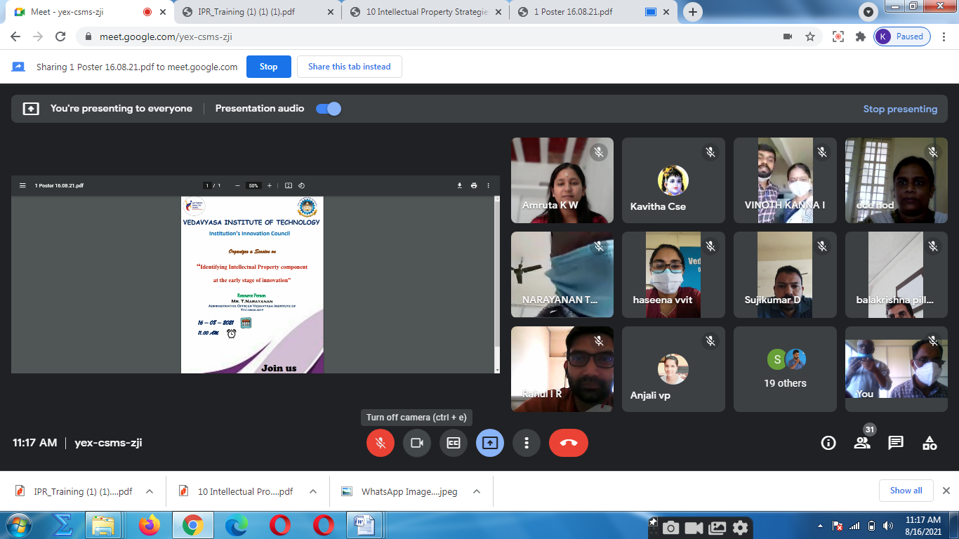
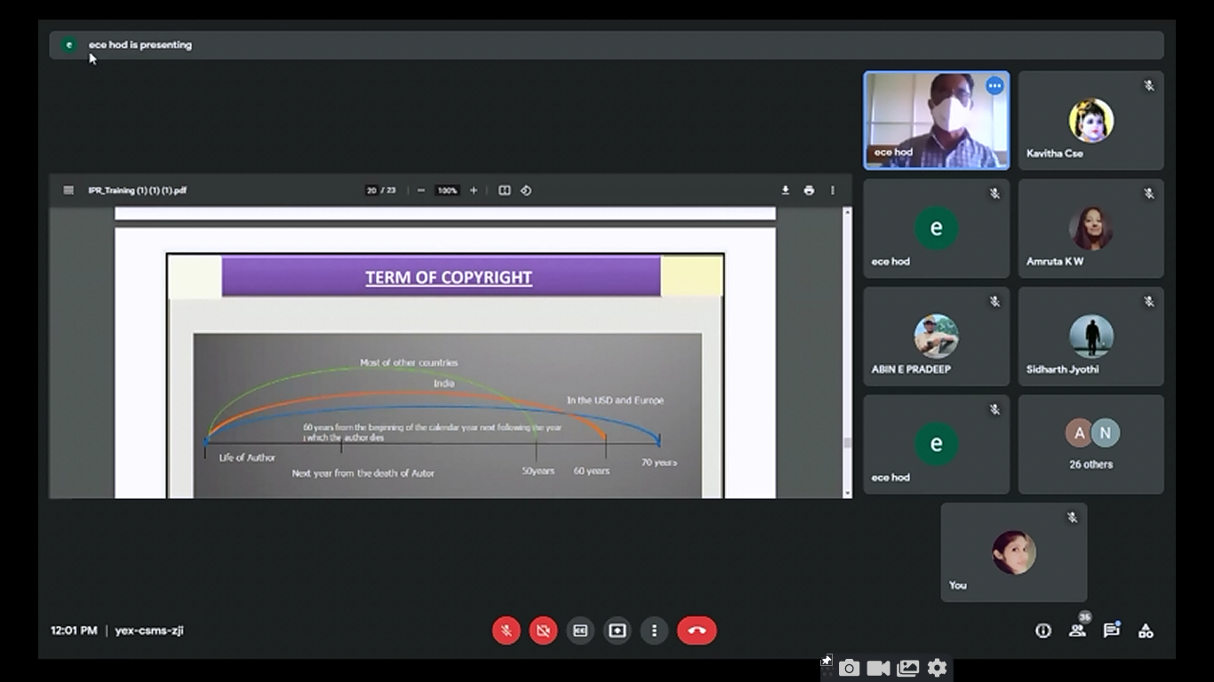
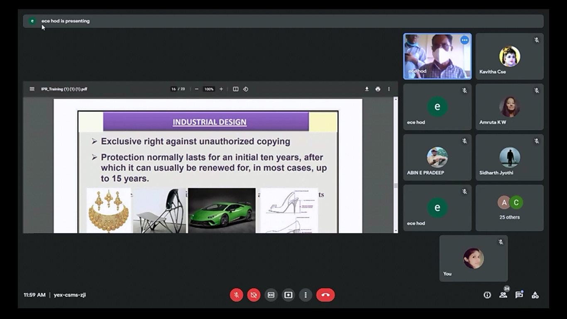
The activity was conducted during this semester and has given added benefits to student and faculty participants.

Dr S. Sangheethaa
Principal
Date 16.08.21

